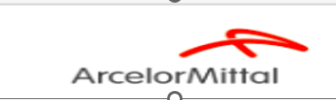

CUSTOMER MASTER DATA- CMD PROCEDURE

Document Title: | ArcelorMittal
Template Version: | 1
SOP Created date: | 22 May 2026

ArcelorMittal
AMDS-FINANCE-OTC-CUSTOMER MASTER DATA-CMD-FRANCE
Project | AMDS- FINANCE -FRANCE
Company | ArcelorMittal Corp ltd.

Table of Content:
- Process Overview
- Process Introduction
- Business Content
- Service Level Agreement-TBD
- AR- CMD- Customer master data-France
5.1-Process Flow
5.2-Process Tools and Application Links
5.3-Procedure
5.1- Entity FR10
5.2- Entity FR01
5.3 -Entity FR06- Is in progress

5.4-Example of customer account Block
5.5- Checklist-In Progress
5.6- Escalation
Waiting for the Entity FR06 -ARAMIS example – SOP is in progress.
1.Process Overview:
Customer Master Data refers to the centralized information maintained for each customer in the Accounts Receivable (AR) process. It includes details such as customer name, address, contact information, payment terms, bank details, tax information, Siren/Siret credit and company/society codes.

2- Process Introduction:
Customer Master Data (CMD) is a key process in Accounts Receivable (AR) that involves creating, maintaining, and managing customer information within the financial system. The CMD process ensures that all customer-related data is accurate, complete, and updated to support smooth financial and operational.

3.Business Content:
- Customer name and address details
- Contact information (email, phone number, contact person)
- Customer account number/customer code
- Payment terms and payment methods
- Bank and SEPA mandate details
- Credit limits and risk management details
- France-Specific Legal Content (VAT, SIREN-9 Digit, SIRET-14 Digit, Legal Form SARL, SAS, ETC.
- VIES VALIDATION OF TVA NUMBER PER VIES- European Commission.

4: Service Level Agreement-TBD- Discussion is in progress.

5.1: AR-FRANCE - CMD- Customer master data Flow chart
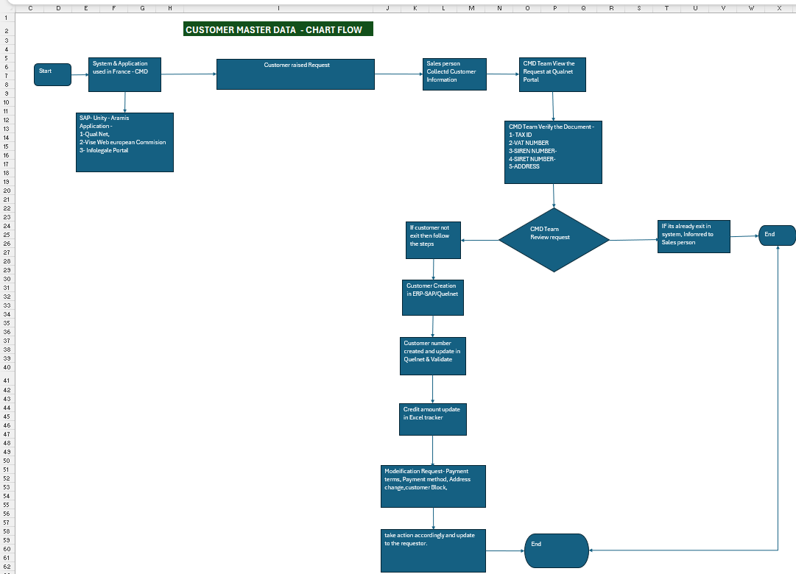

5.2- Process.
Application | CMD Details | Reporting | Customer Queries | Contact Details
SAP | Yes | No | Yes | Yes
Application
QualNet Application | Yes | No | Yes | Yes
Vise Web European Commission | Yes | No | Yes | Yes
Infolegale Portal | Yes | No | Yes | Yes

5.3-Procedure:
- Open all the above Application to cross verify the customer details.
- QualNet- Receive customer creation and modification requests with the relevant supporting documents attached.
- KBIS,
- letterhead,
- Purchase order or any other document.
- Bank document – For bank number updating

- SAP - Log in to SAP to check customer status and create new customers.
- Vise Web European Commission-To check the Customer siren number, VAT number and address.
- Infolegal – To cross check address details with Siren number.
- Quel Net Application: Use of CMD new setup and modification request
- Application links:
Application | Links
QualNet Portal | Identification
Infolegal Portal | Connexion - Portail Infolegale
Vise Web European Commission | Vies on-the-Web - European Commission
Too find out Siren, Siret and Vat number | Société APS GAMBETTA à 06700 SAINT-LAURENT-DU-VAR - SIREN 910 234 988 | L’Annuaire des Entreprises
AVIS Siren- To find correct Siret number as per address details | Accueil | Avis de situation Sirene | Insee

1. Log in to Quelnet to review the daily SOD and EOD work volumes.
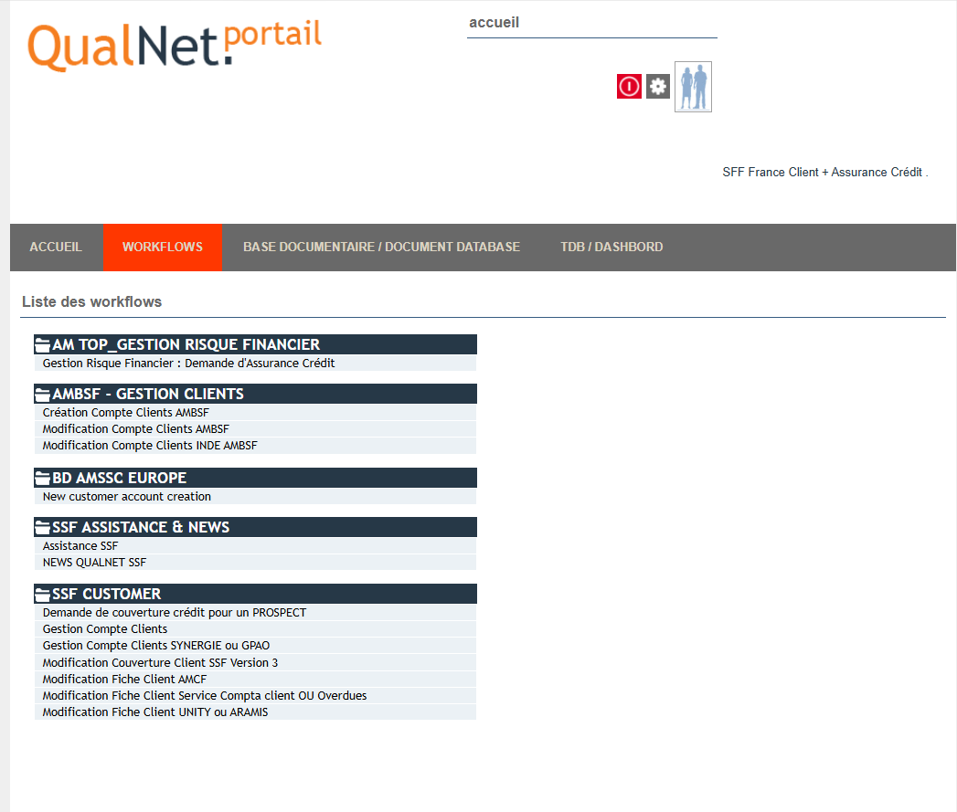

- For Entity FR01 only work as per below screenshot: AMBSF-GESTION CLINETS
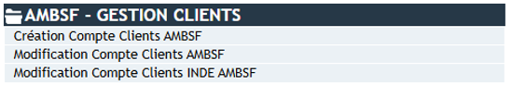

- For Entity FR06 work as per below screenshot-NEW CUSTOEMR ACCOUNT CREATION
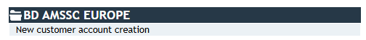
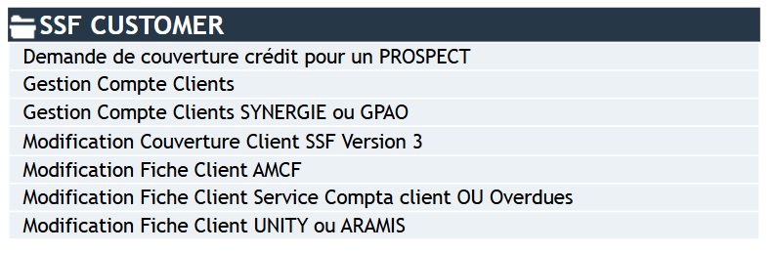
- Gestion Compte Clients (Customer Account Management): Set up new CMD accounts and duplicate existing accounts for Entity FR10.

- Modification Couverture Client SSF Version 3 (Modification of Customer Coverage in SSF Version 3)- Credit assigned to the customer.

- For Entity FR10 & FR06 - Only customer modification request cases.

- Now check the process steps of the Entity FR01 Volume.
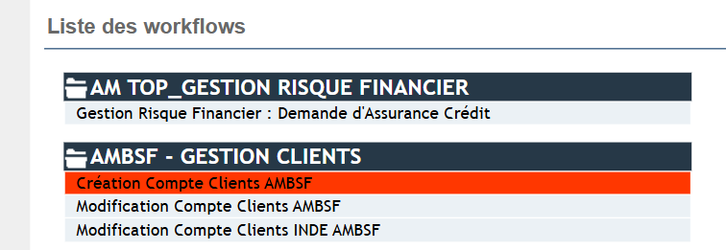
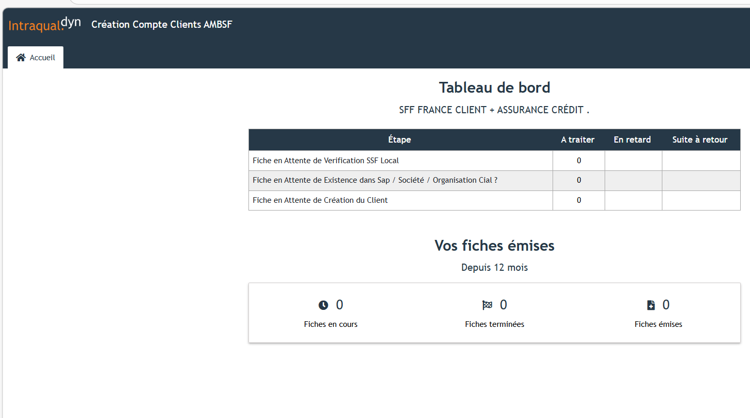
- No Records found.
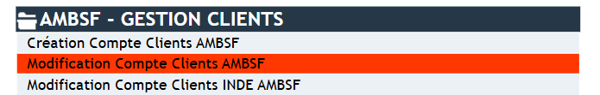

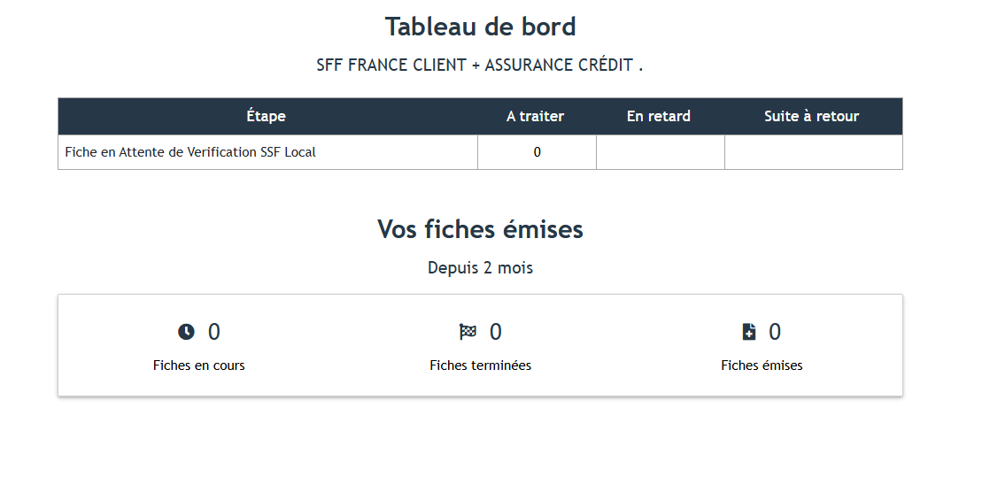
- No Records found.

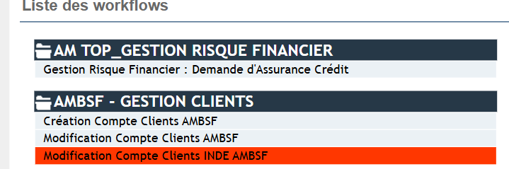
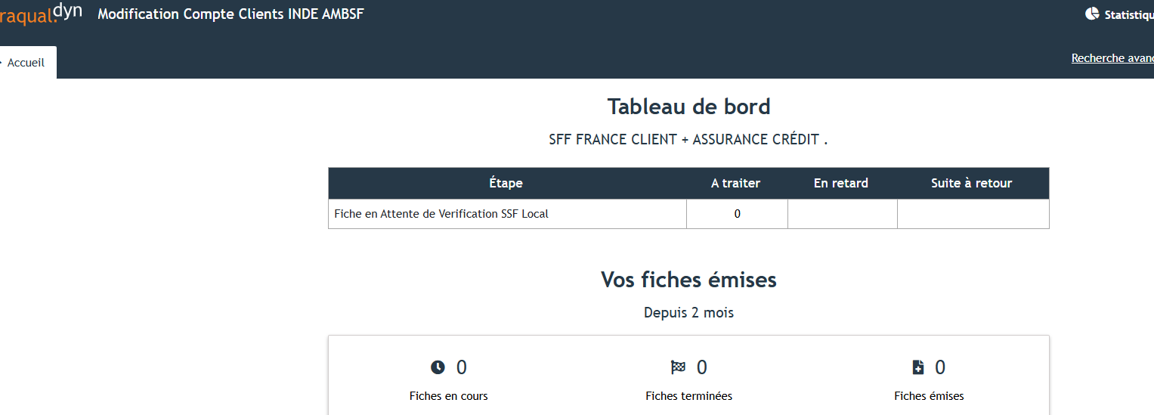
- No Records found.

- How to create a customer account in the Customer Master Data records for Entity FR10.
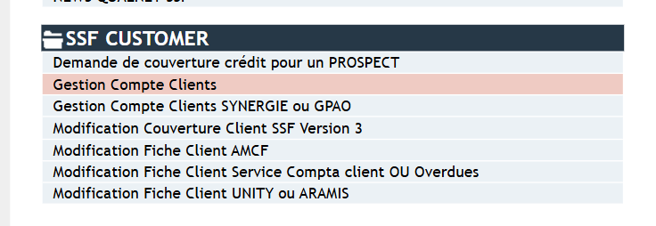
- Found Records – A Traiter- Awaiting Action
- En Retard - Delayed
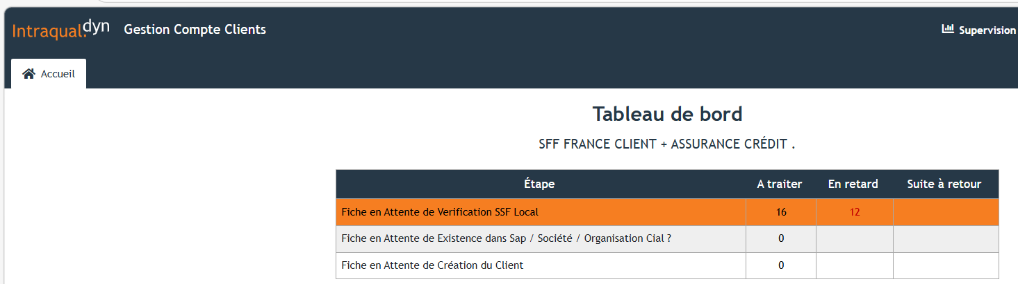
Workflow

- Work Volume:
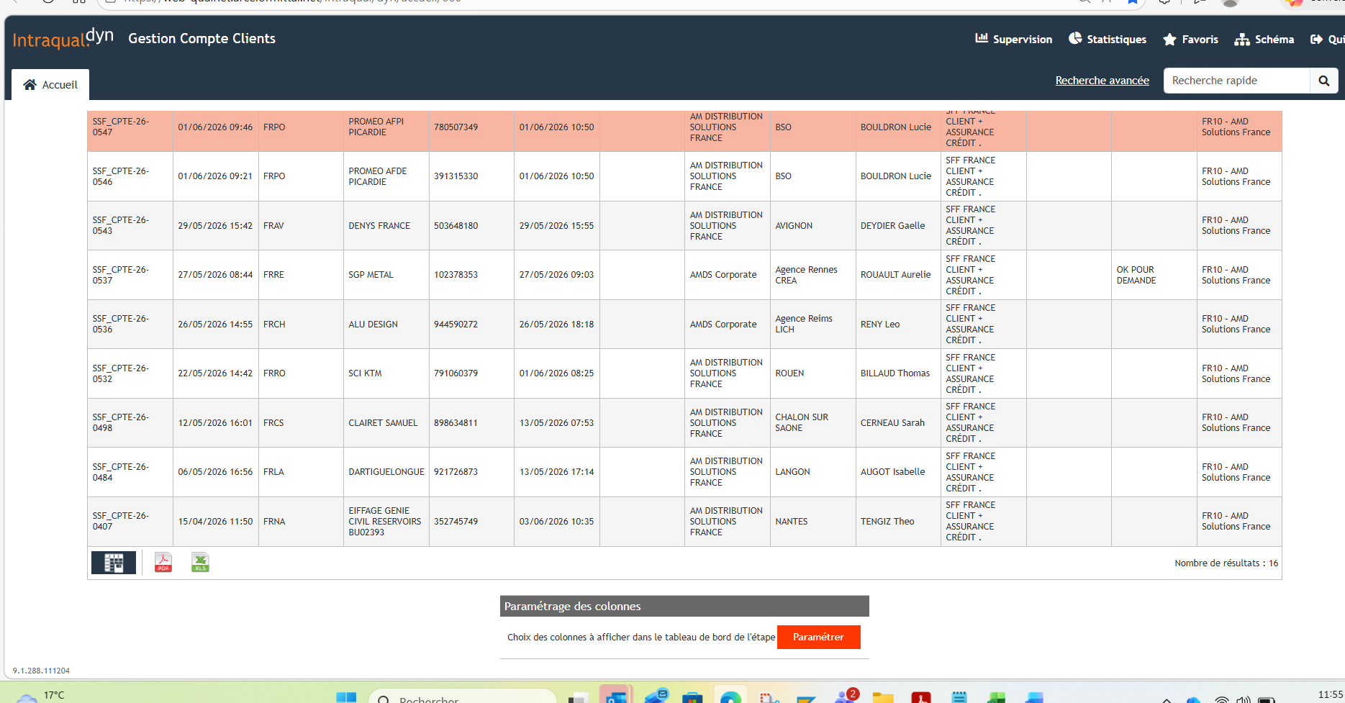

- Click on CMD cases to proceed with customer record creation in the system

- After clicking on Case, you will see the screen shown below.
- To view the Legal document – Click on Document Join - Document attachment
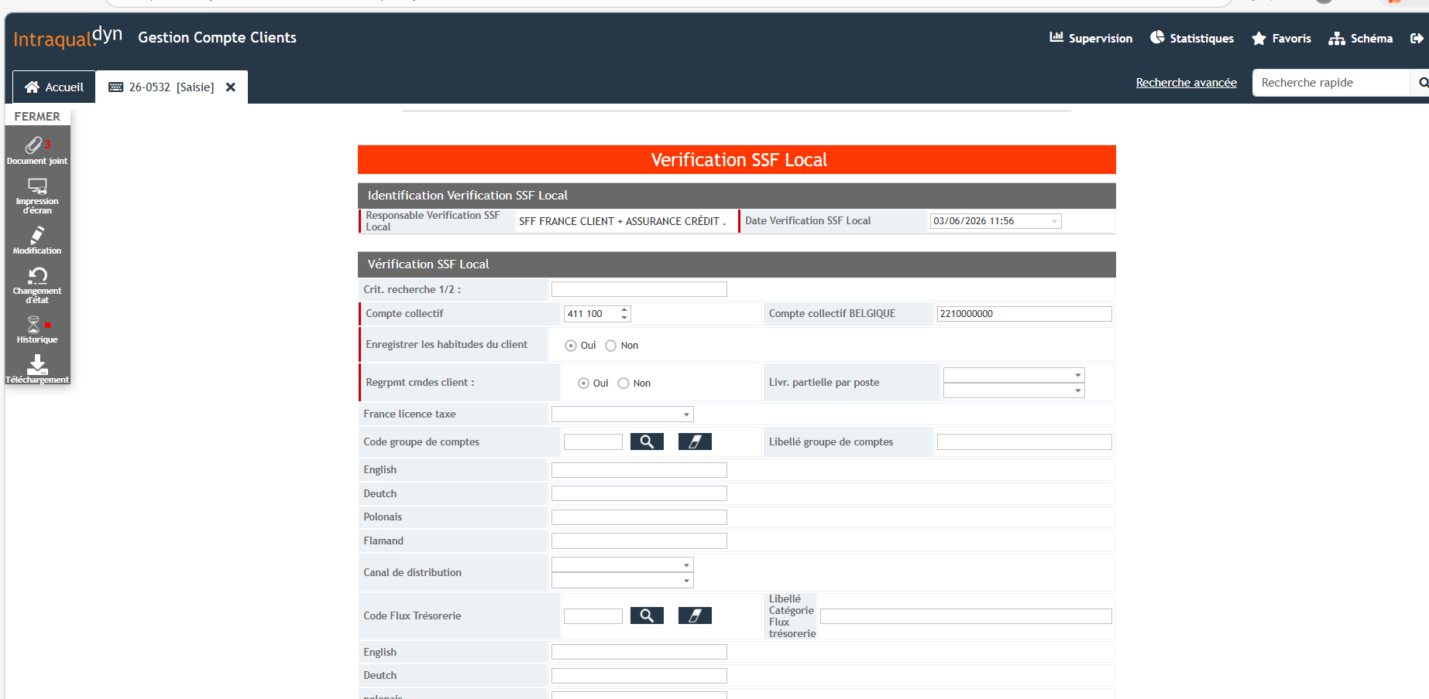
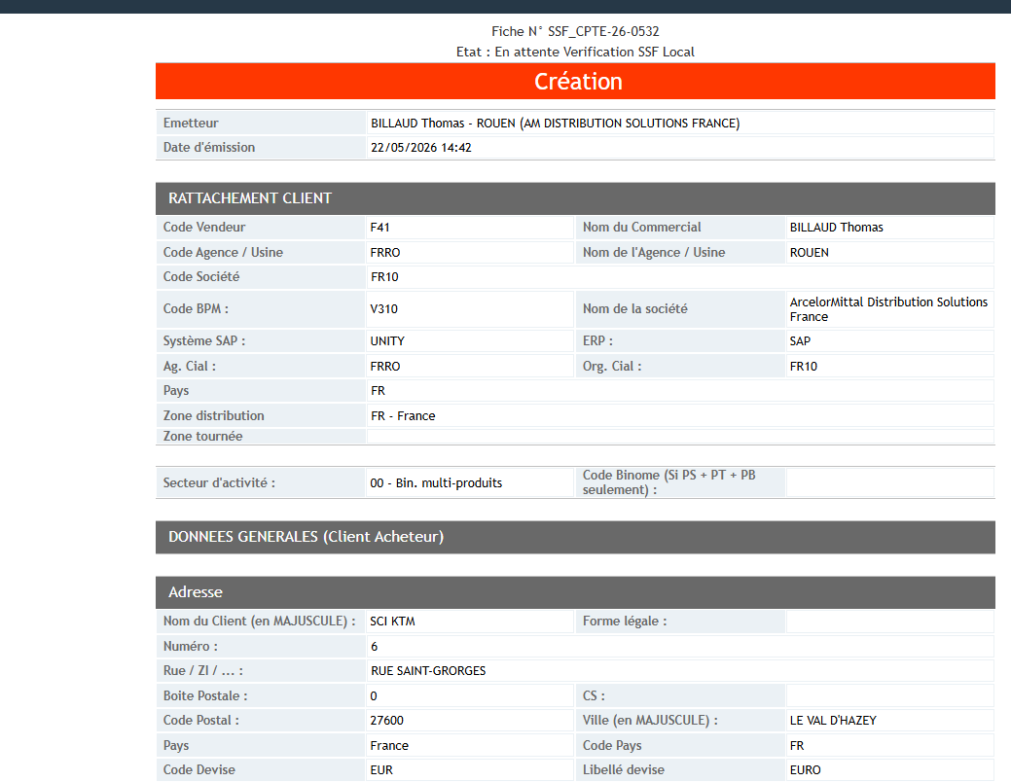
Siren No Siret No
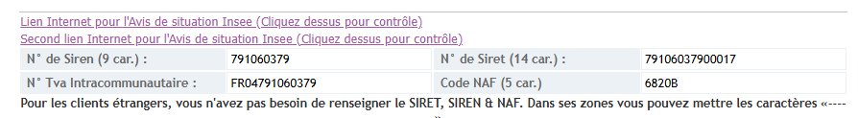
VAT No

- Comments Box

- Now Login into Infolegale Portal to check customer status and details with 9-digit siren number.
- Copy past Siren number and Enter
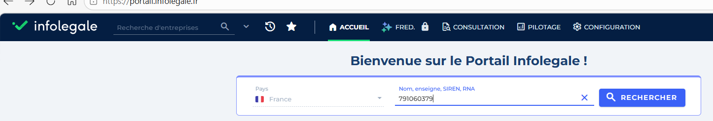
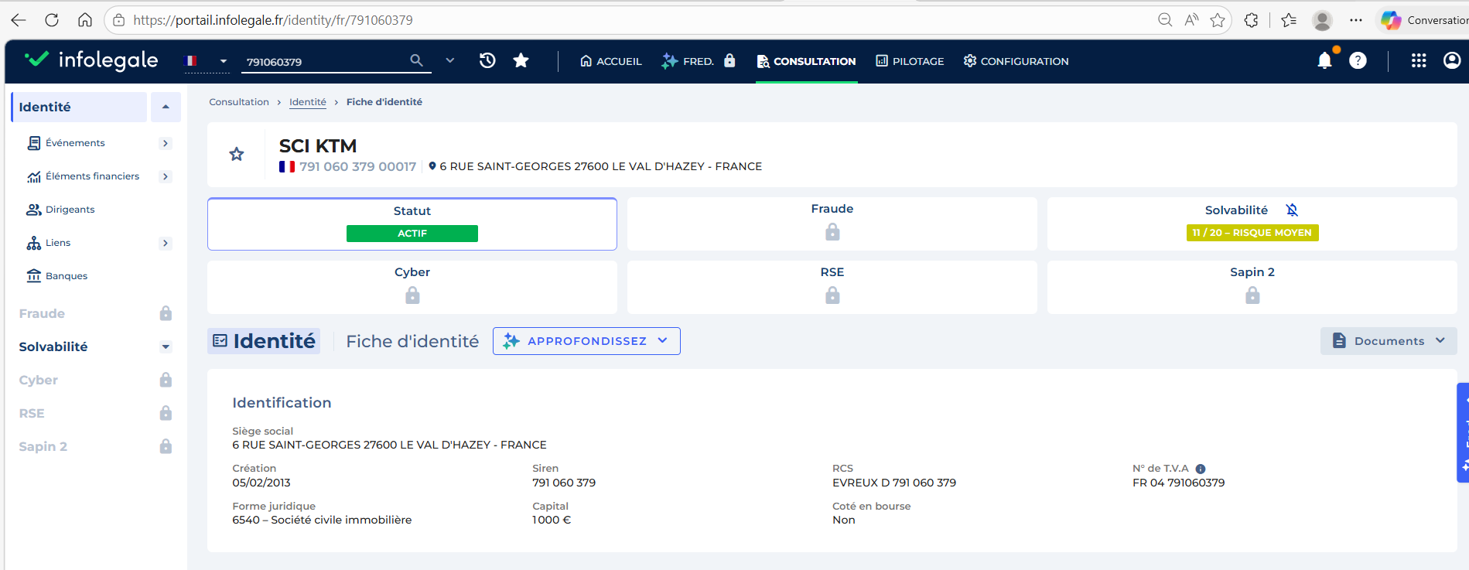
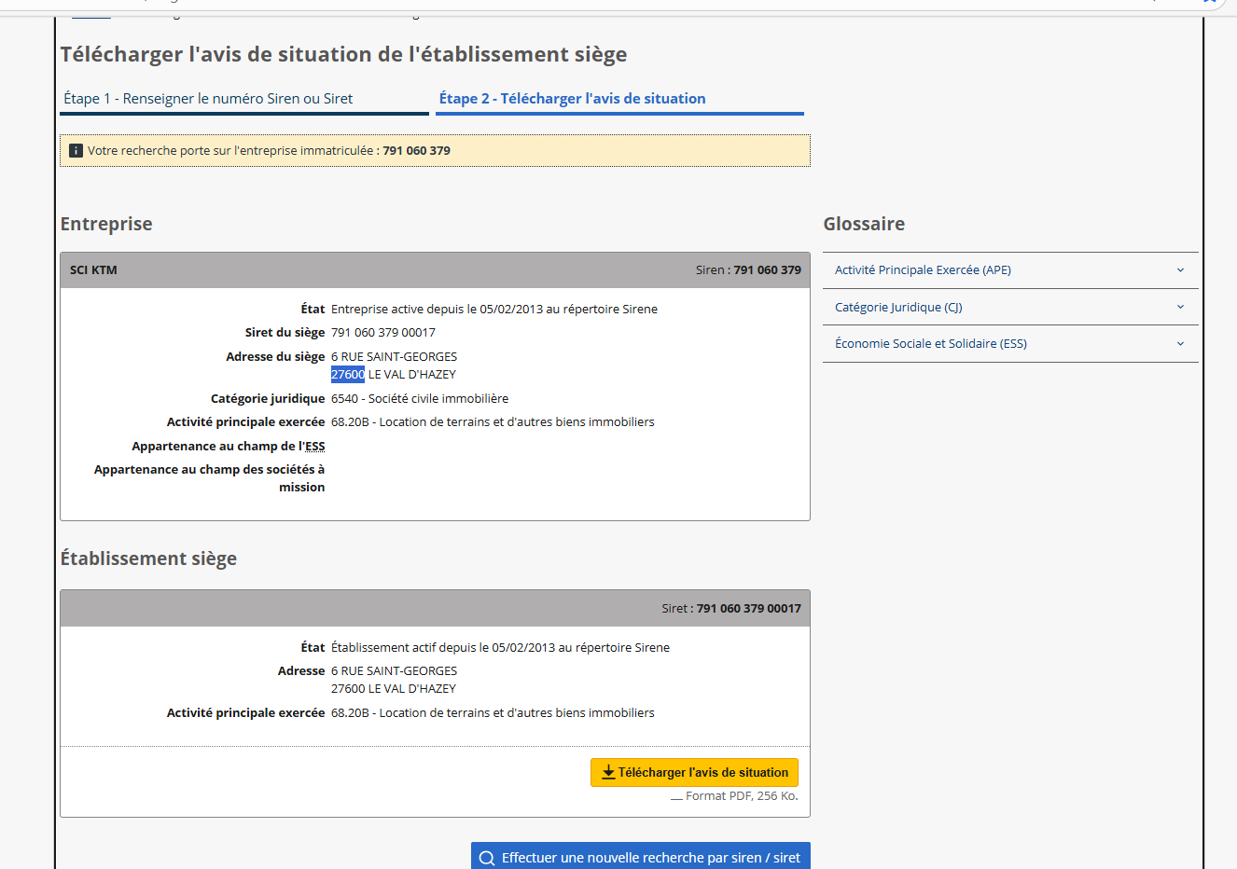
Click here-Download doc.

- After verification, review data in SAP via XD03
- If customer already exists in SAP with same name, SIREN, VAT but have different SIRET and bank details then create new customer in SAP.
- How to Login in SAP- Steps as below: Click on SAP symbol
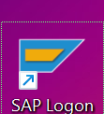

- Click on ECC Unity Production – DSP Production- DSP EXTRA

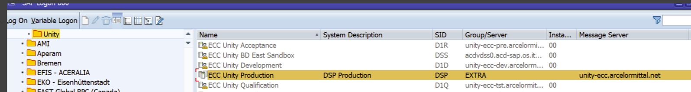

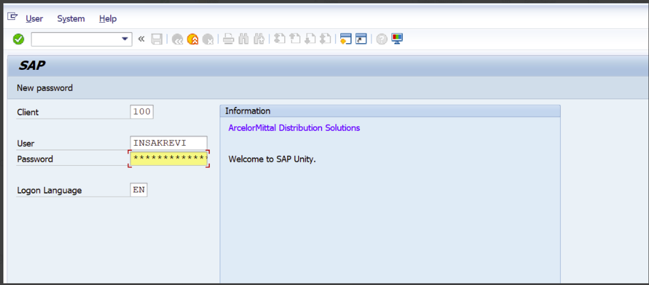

Enter T-Code

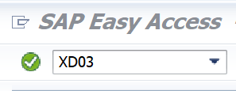
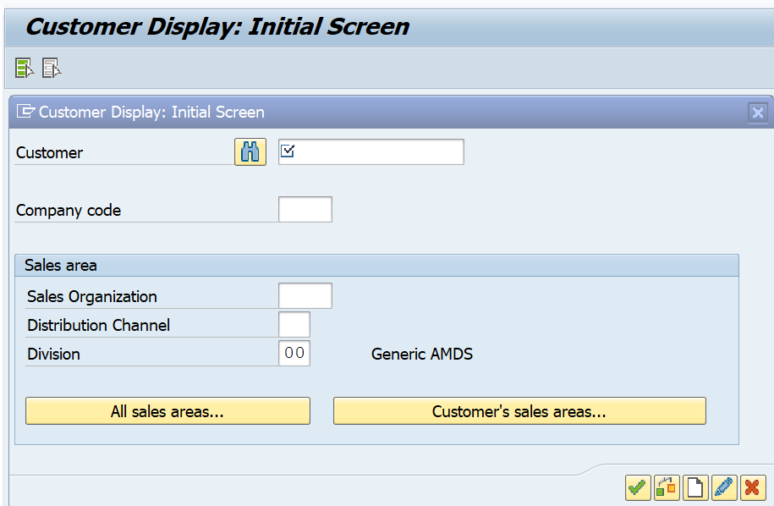

- Check if the customer exists in the system or not.
- Hit Enter or Click on Execute
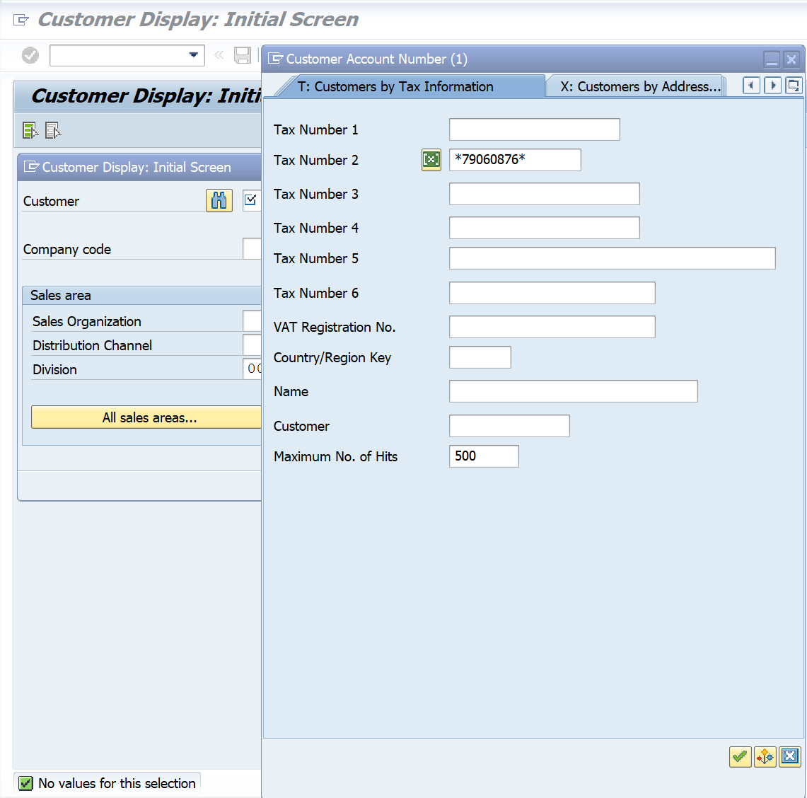
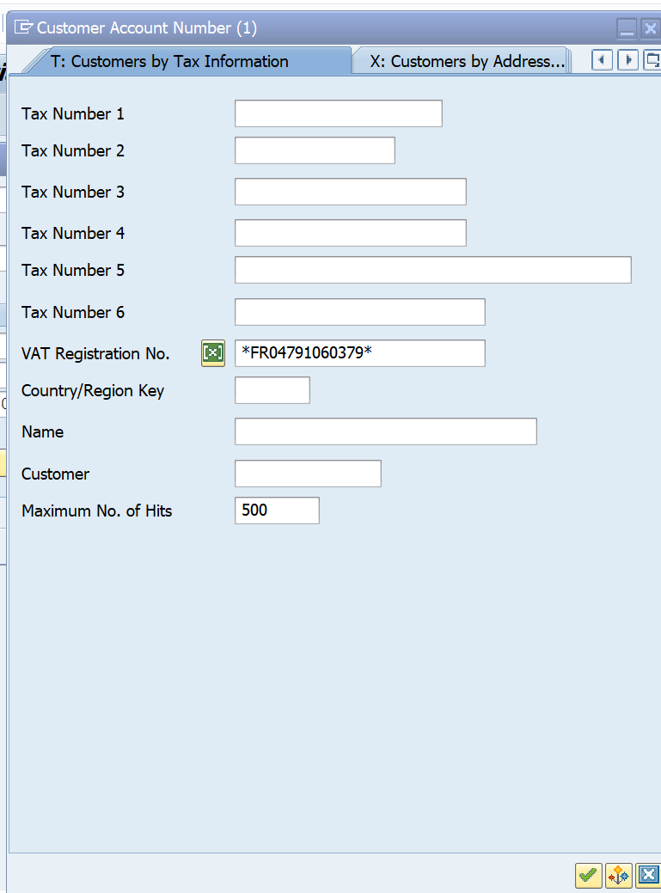

- If no customer record is found, then create a new record in system.
- T-Code - BP
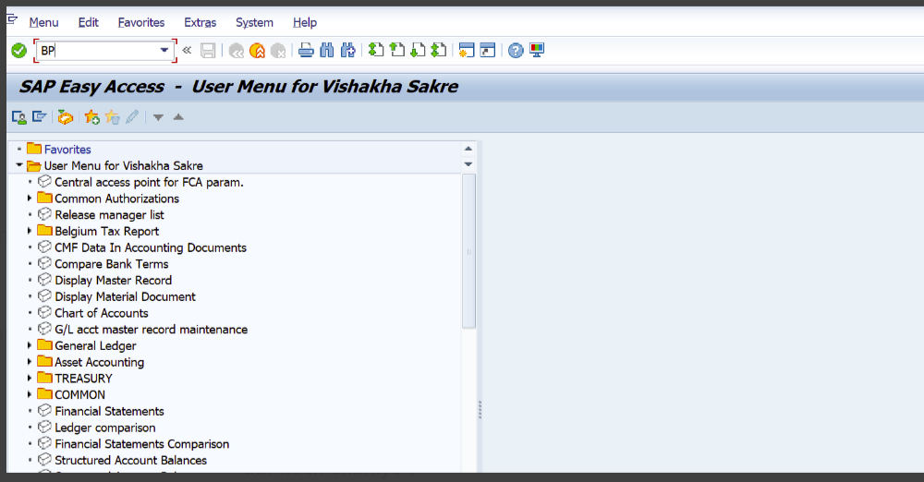
SAP ALWAYS IN CAPITAL Letters
Now click on Organization
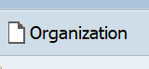
- Create in BP Role – 000000 Business Partner (Gen)
- Grouping – YB01 Legal Customer
- Click o Address Tab – Update address details as per document.
- Check all spaces in tabs
- If we have long name full name we have to take it with 2 lines, and in search term 1 or 2 words

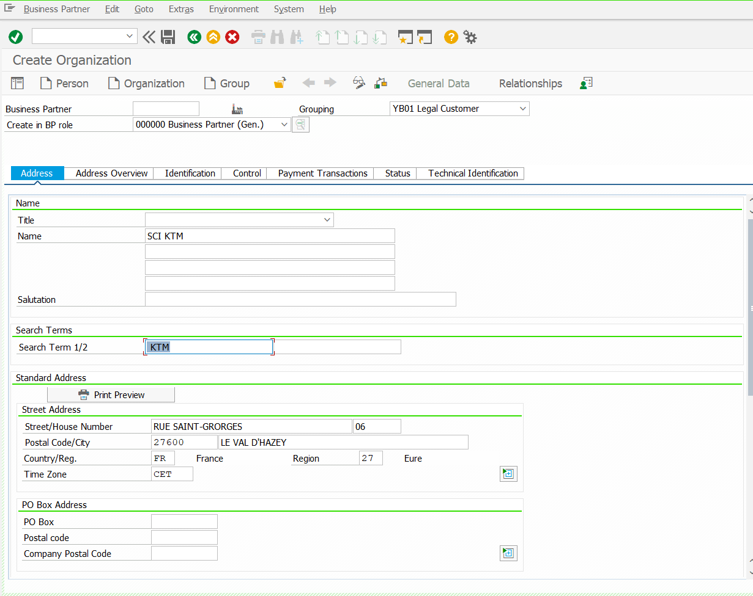
Cust, address update
Cust, First Name only
Cust, Name
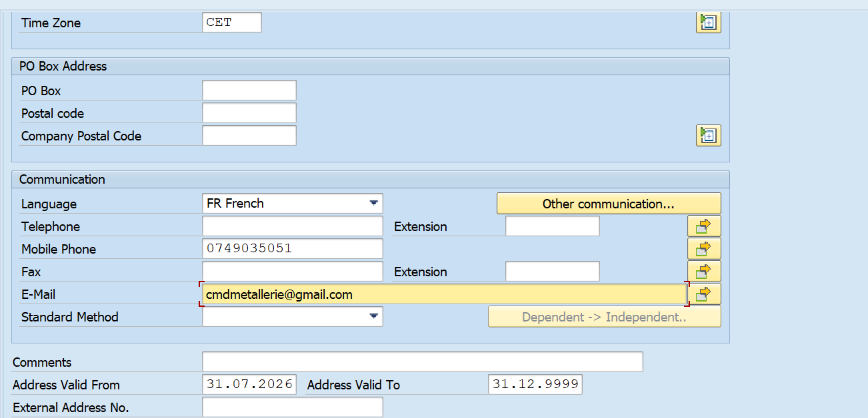
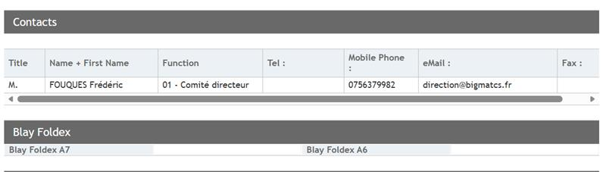

If we have an email address in contact in qualnet, then we write it in address page

Telephone no is from 01-05
Mobile no. is from 06 and so on.

- Click on Identification Tab- To update the Tax Details.
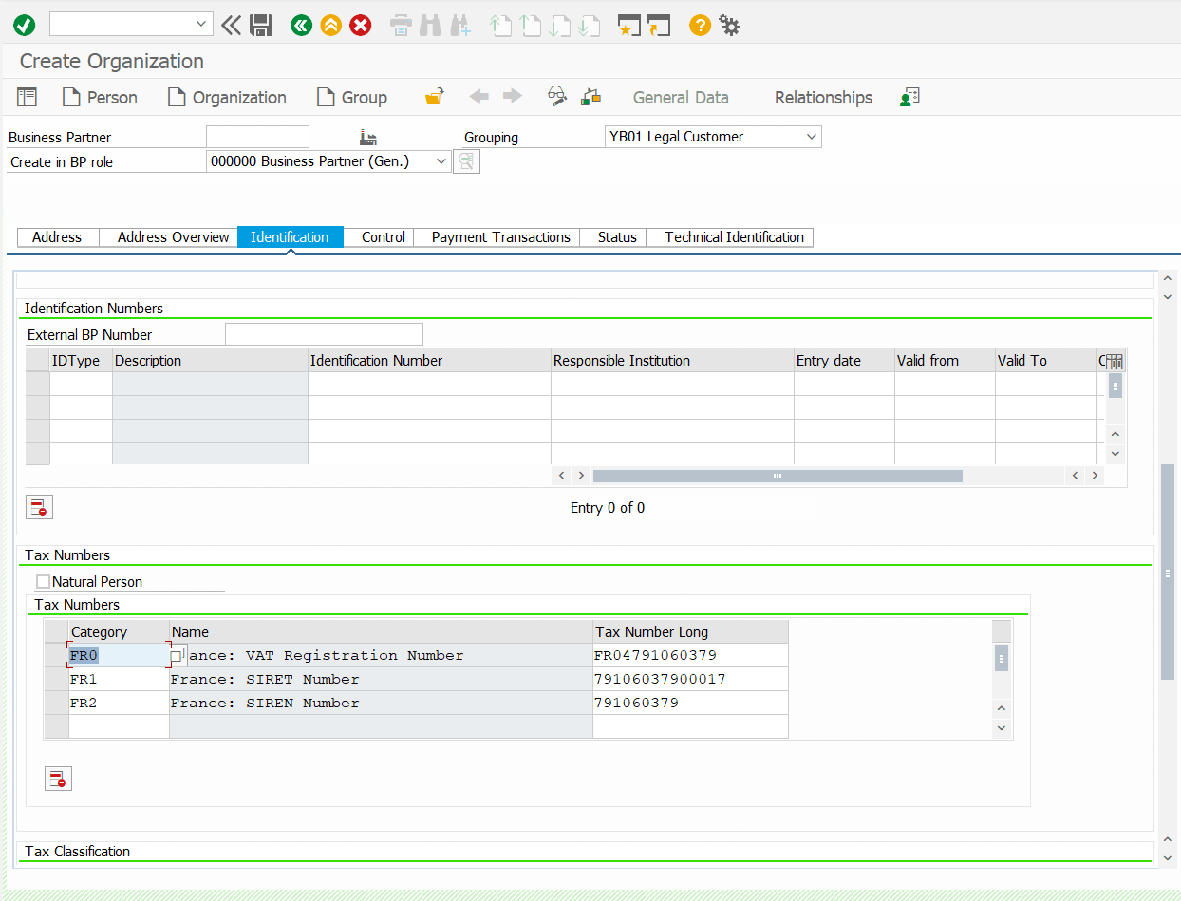
- Go to Payment Transaction tab – To update the Bank details.
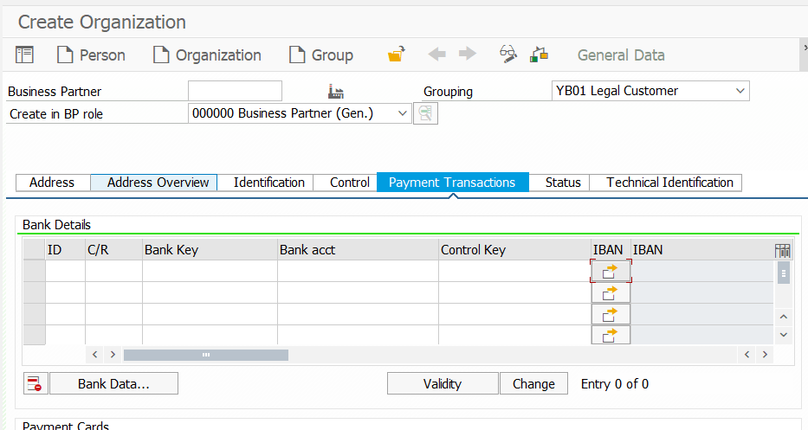
Click

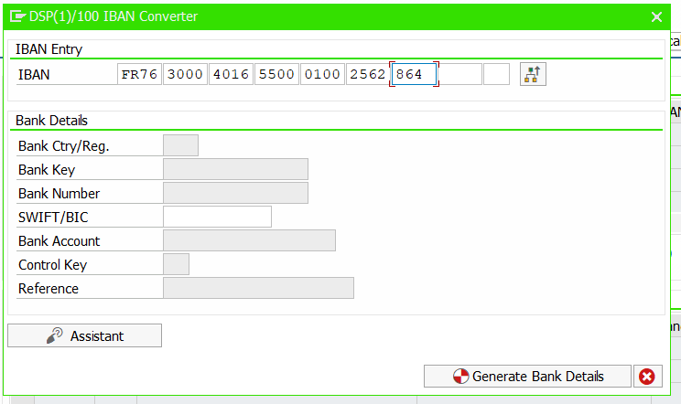
Click
Click
- First change the BP Role: ZCU001 FI Customer – Then Click ok Save
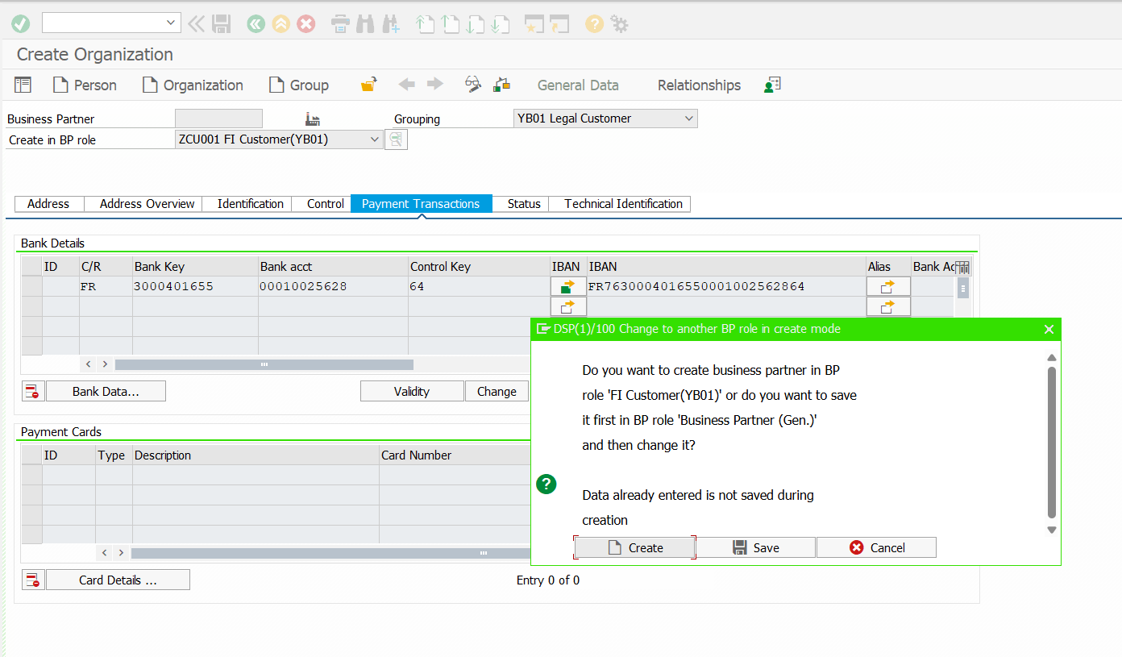
Click Save

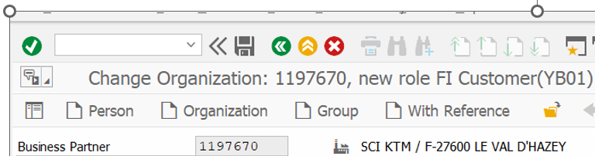
- Noted generated customer account number.

- Now Click on Control Tab – Trading Partner No. CLI

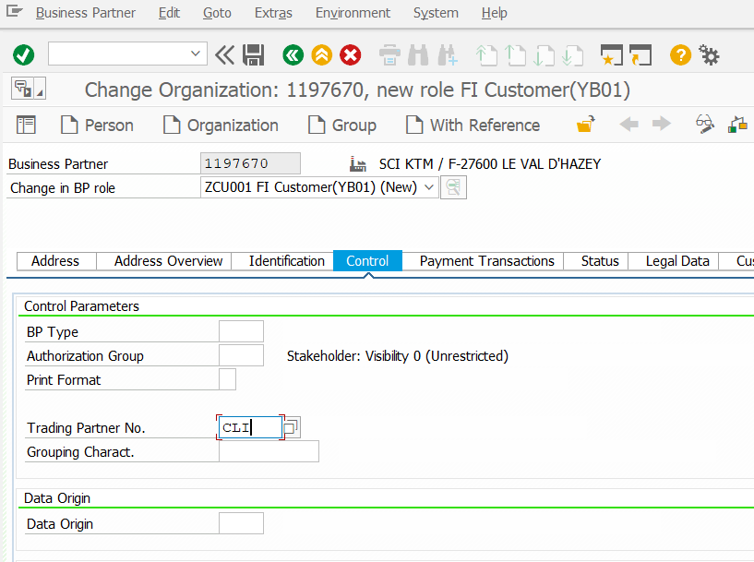
- Saved and Click on Company Code

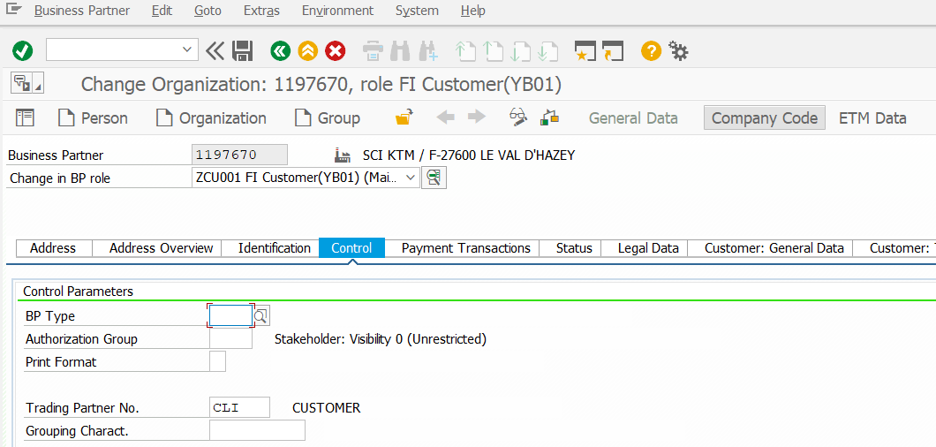

- Customer: Accounts Management Tab

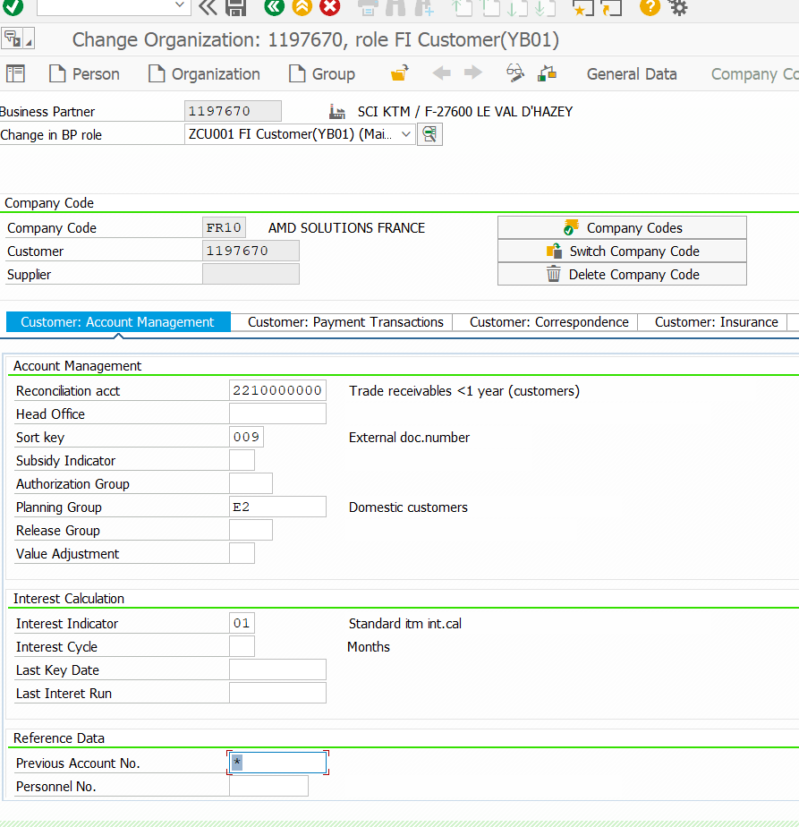
Default’s – Reconciliation Acct,
Sort Key
Planning Group
Interest Indicator
for FR06 & 01 sophie no will be used in previous account no instead of *

- Customer: Payment Transaction Tab
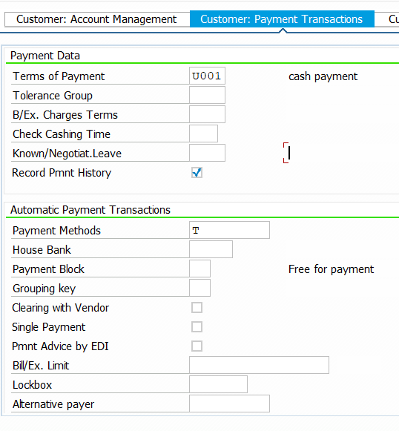
- Regarding LCR DIRECT, the following rules are mandatory:
- The protocol must be properly signed
- It must be properly stamped
- The date must be up to date
- If the document is missing the record must not be saved as “S” in SAP, SAVED ''NP''
- For Credit card/Bank card – T

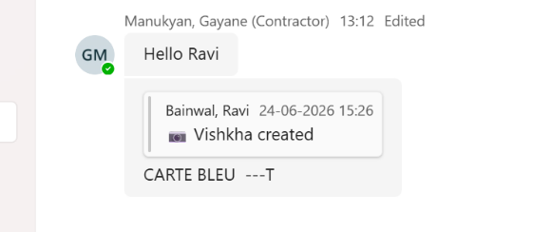

- Customer: Correspondence Tab
- Dunning and Accounting clerk – As per Agency / Plant Code – Below excel sheet screenshot: Code GC- Accounting Clerk and Code RR- Dunning clerk and
- Centre Profit- Agency/Plant code – As mentioned in the QualNet application form
- X`X`. 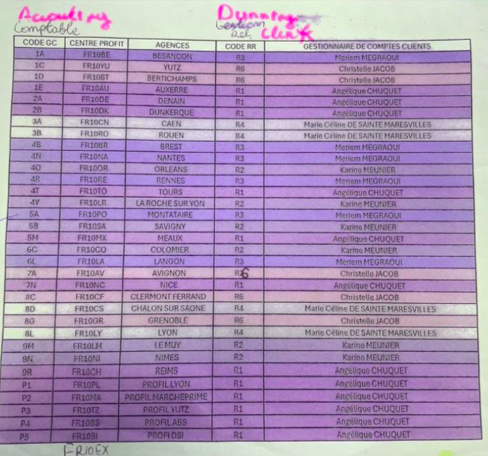
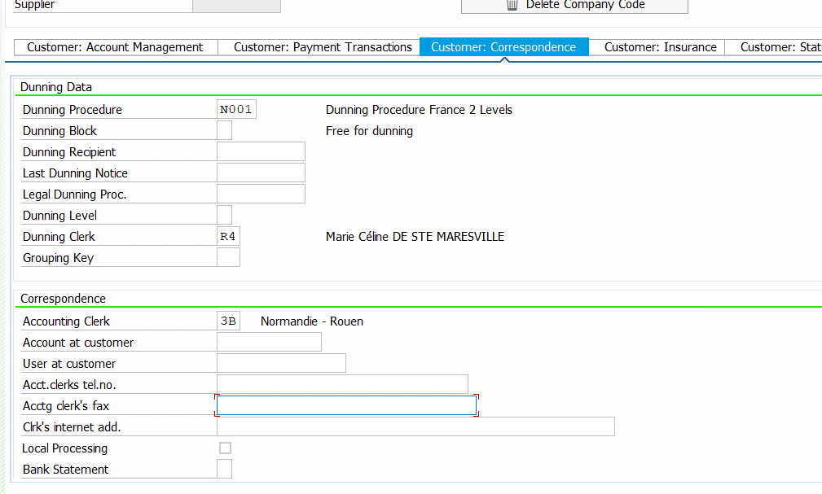

Saved
- Now change the BP Role: ZCU101 Customer (YB01) NEW
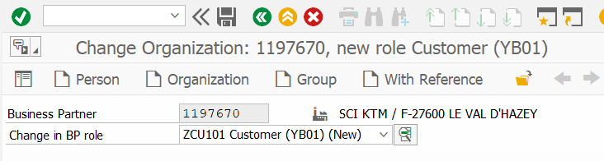
- And click on Sales and Distribution
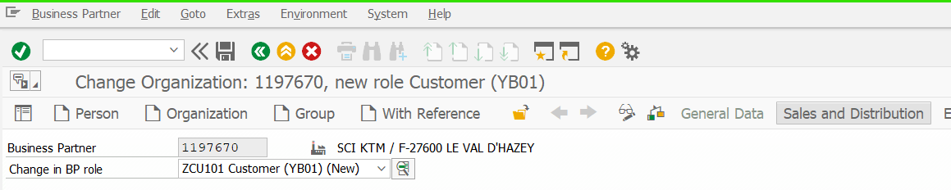

- Update the Sales Area and Enter – Go to Order Tab

- Update the Sales Area and Enter – Go to Order Tab

- From 1A to 9R: FR10 01 00 (General) creations.
- From 9R to P5, P1: FR10 01 01 (Business) creations.

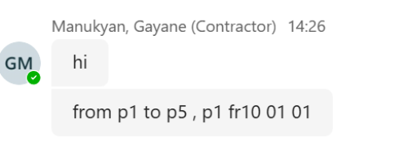
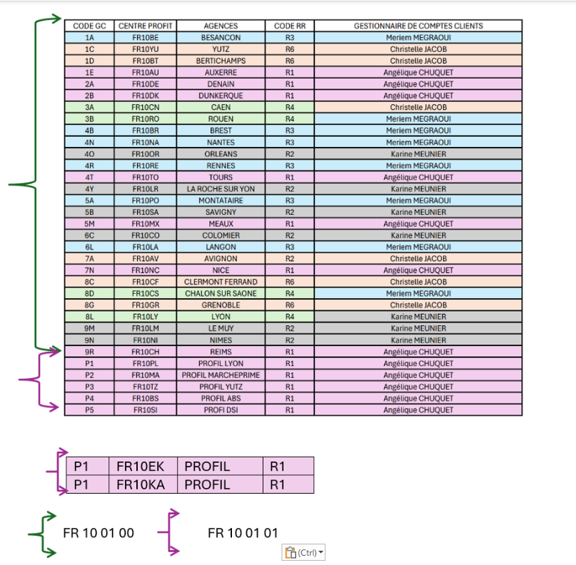
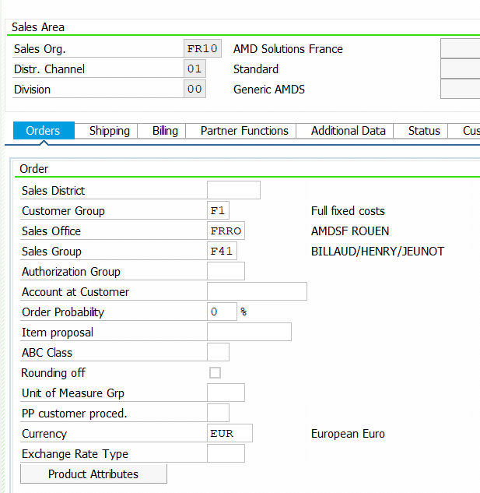
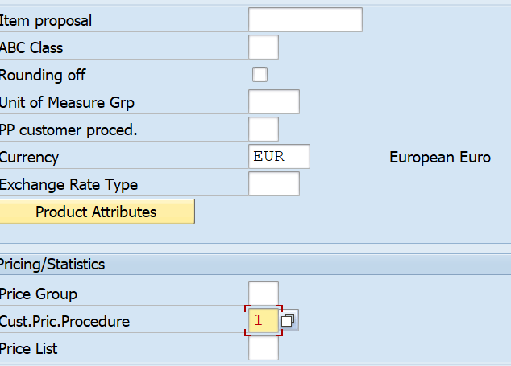

Customer group –
Frais Fixes de Facturation
Fixed Invoicing Cost
100 % = F1
50% = F2
If NON then leave it as blank
Order Probability should be 0 %

Sales group is taken from Salesperson Code in Qualnet
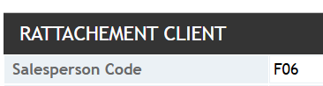

- Go to Shipping Tab
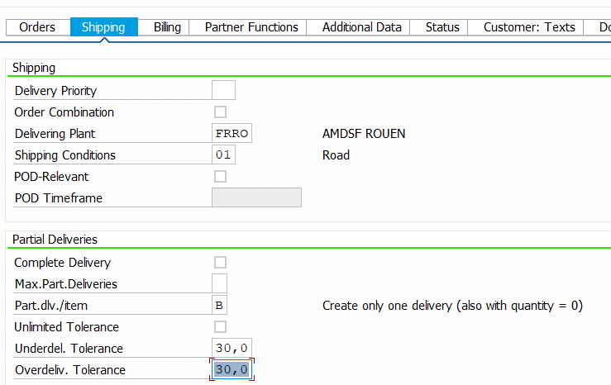
It’s by default

- Billing Tab
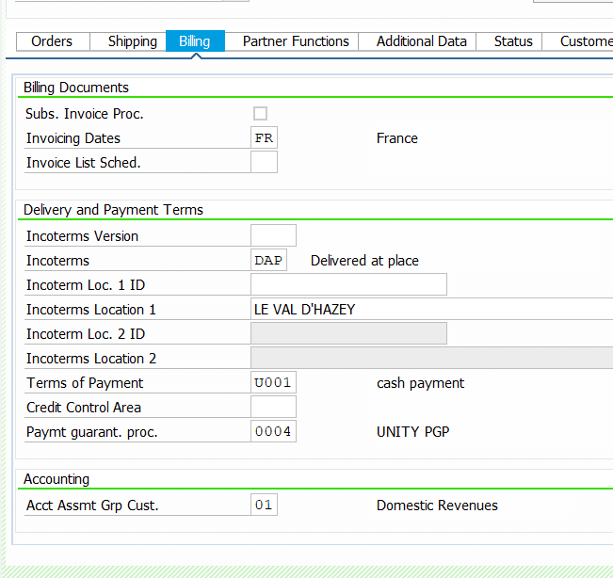

Default’s –
Terms of payment
Payment Guarantee proc
Acct Assmt Grp cust.

Cadence de facturation 15 : Facturation à la quinzai
If the invoice frequency is 15 days, then we must take ZM instead of FR in invoicing dates
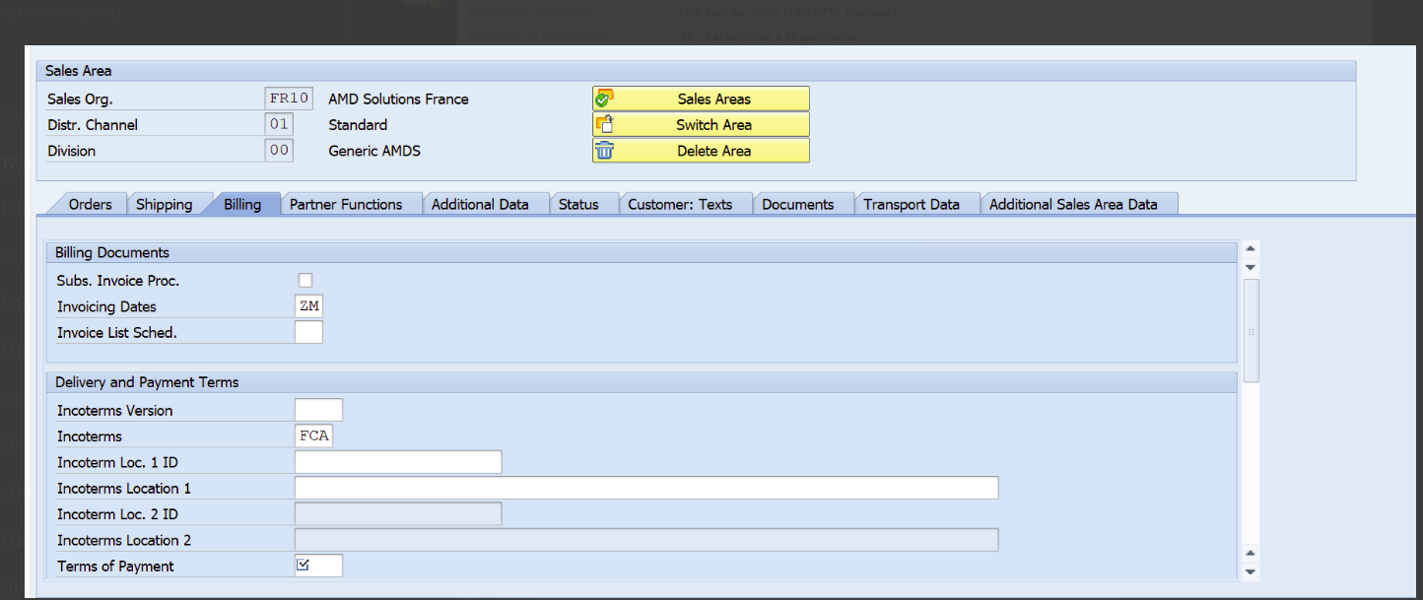
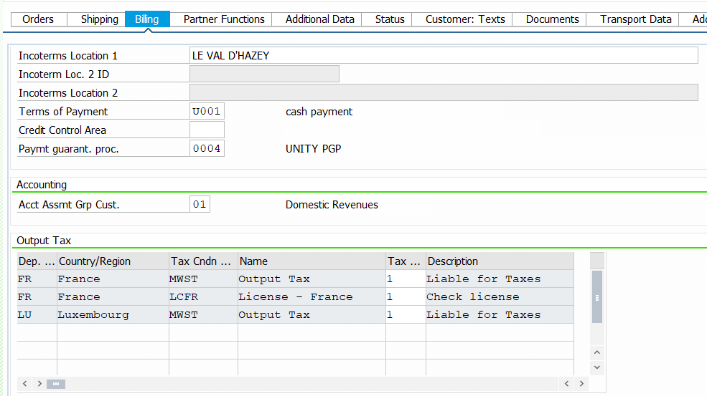

Check Frequency transport: Freight frequency:
- Additional Sales Area Data- Cust Trans Charge-TAI & Code Name -ALL (Always enter "TAI" along with "ALL" whenever applicable.)
Transport Charges | Splitting & Grouping- Invoice
TAI (once month) | ALL
TAD (per day) | SON

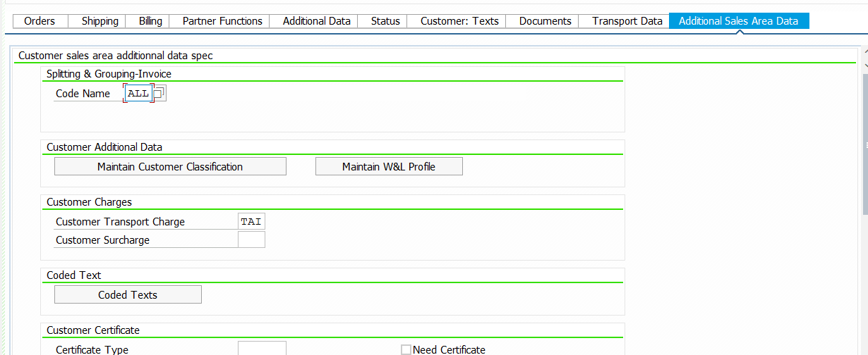

- Click on Saved.
If we have emails for dunning, then add in digital
- Upload all attachments in General data and save.

- Now go back to Quel Net – Fiches Form
- Click on le client est-il du pays - Is the Customer Domestic ?”
- Click on Le Client exist-t-il déjà dans SAP- Does the customer already exist in the SAP system.
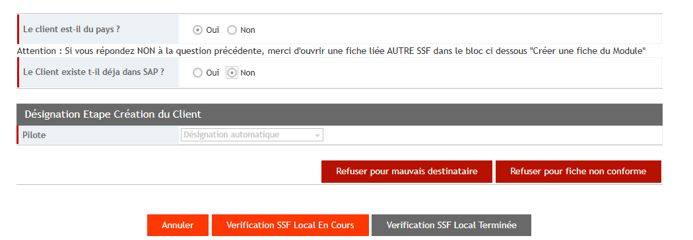

- Once Validated then beck to Tableau de bord – Dashboard
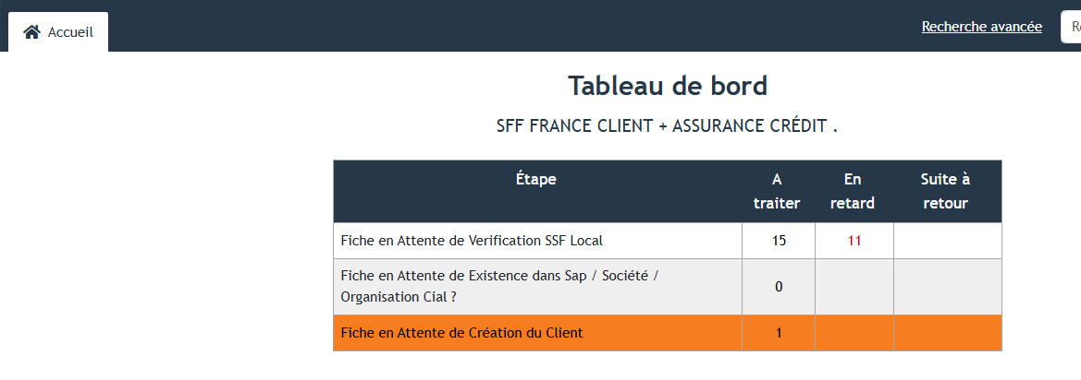
Click here

- Click Highlighted Line
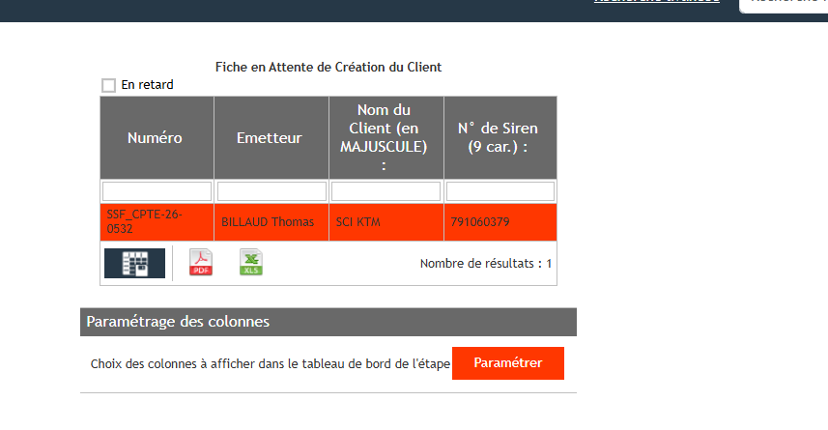
- And update below column with client number and X
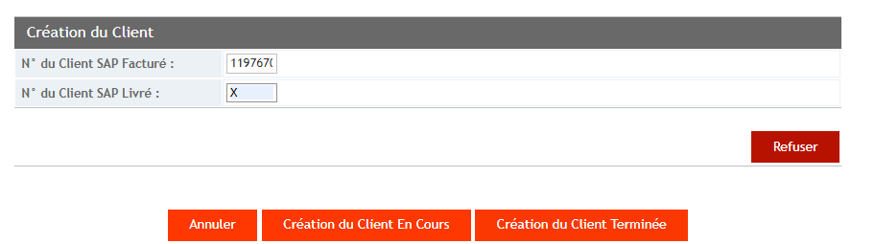

Click here to update

- 5.2-FR01- CMD Creation steps.

- Again, When the FR01 CMD request is received then proceed with the following steps.
- First, review the verification steps for the attached legal document. Cross-check the address, SIREN number, SIRET number, and VAT number against the Fiches page, KBIS document, and any other supporting applications or documents. Ensure that all details are consistent and match across all sources.
- T-Code: XD03 – To cross check the details for avoid duplicate entry.
- Check via – Siren Number, VAT number, Customer Name, Customer Postal Code. If not found, then start creating the customer account.
- Now Go to T-Code – BP- For creating customer accounts. Click on Organization
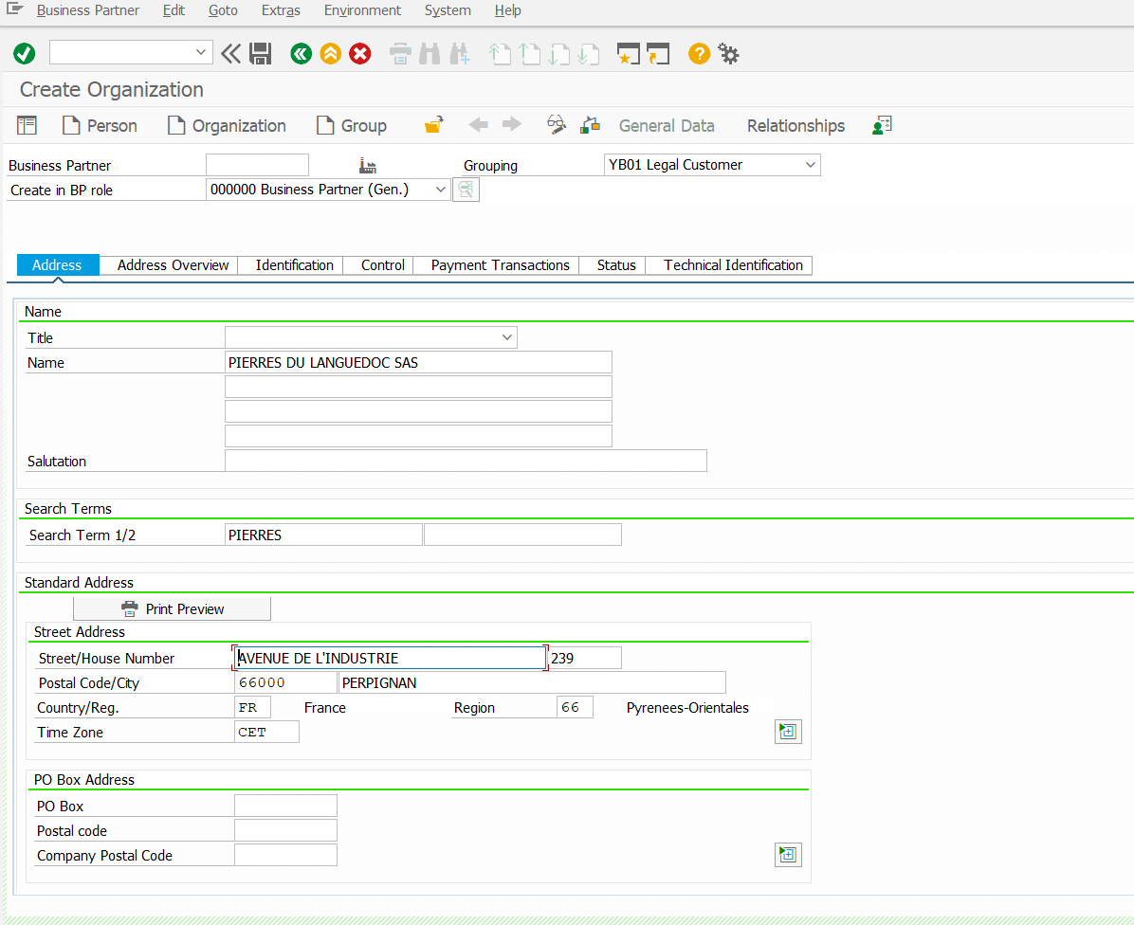
Cust Last Name

- Now Update the details as per below TAB.
- Make sure IF Mobile number start with 06 Digit, then update as per Mobile Phone Column
- If its start with other digit like -04,02 then update in Telephone Column.

forme juridique take short form the societe par actions simoplifiee as (SAS) or as per the name take the short form.

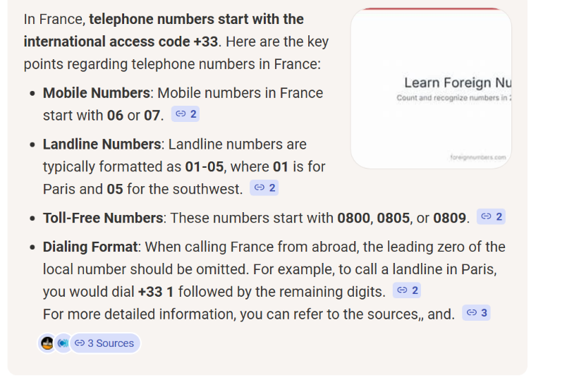

- Address Tab
whenever address is changed, we need to change the last two digit of Siret not as well
whenever the address is changed attach the document provided by the customer.
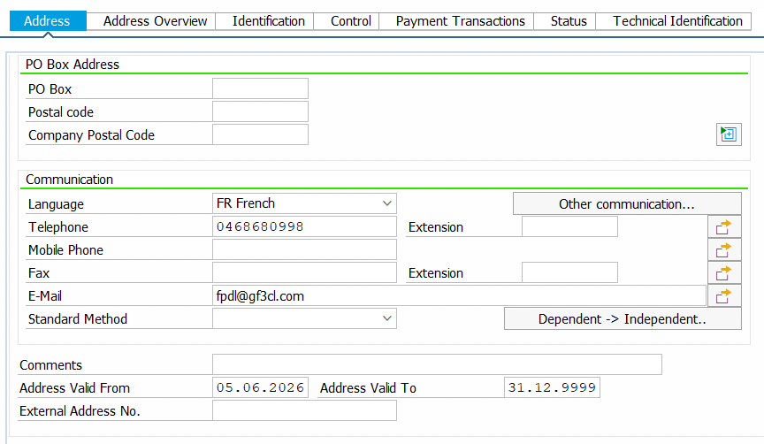
- Now go to Identification Tab

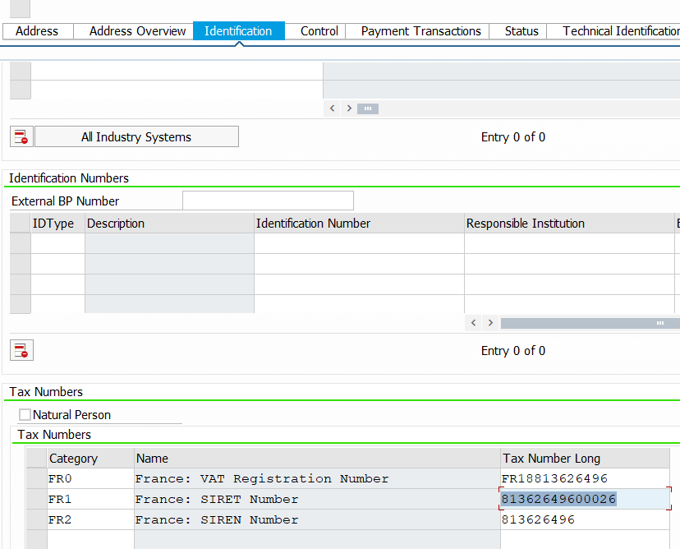
Siren No
Siret No
Vat No

- Update the Bank details, ensure that both legal documents are attached when the payment method is LCR Direct – Mode of Payment, as shown in the screenshot below. Verify that the forms are properly completed and include the required signature, company stamp, and date - S
- If the payment method is Transfer (T) or any other payment method, ensure that the relevant bank document is also attached for reference purposes.
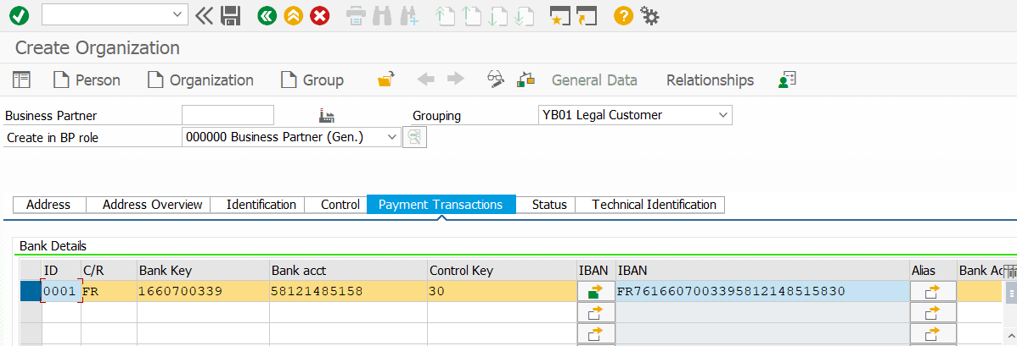
Bank IBAN No.
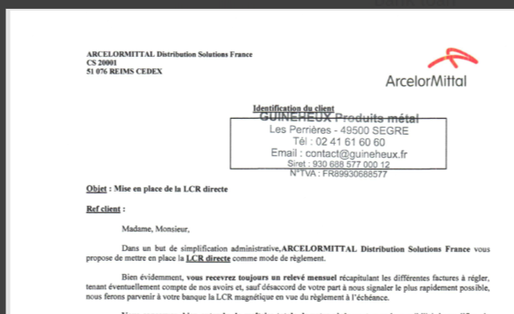
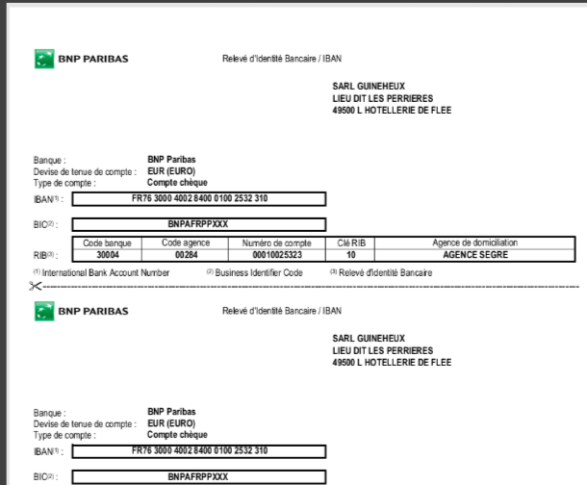
IBAN No.

- First, change the BP Role and saved.
- And saved and note down the Client (Customer Number).
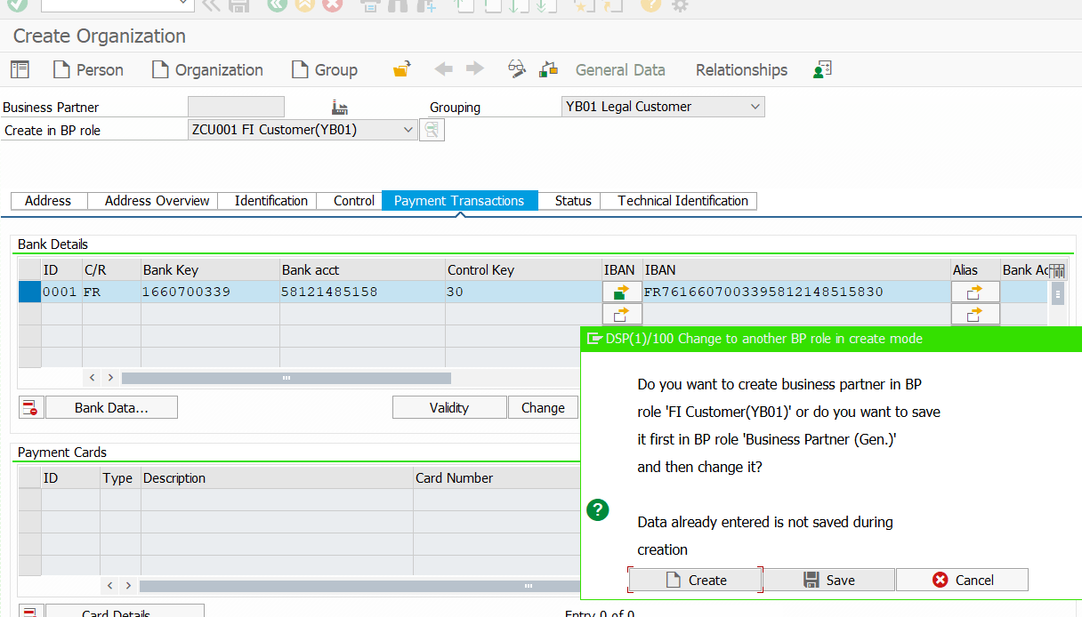
Click on Saved & Note down Cust. No

- Update the CLI under Control Tab

- Now Click on Company code

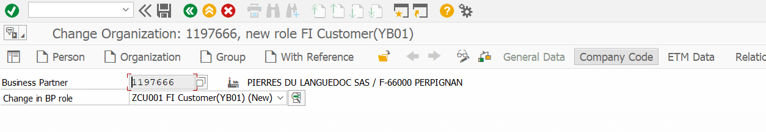
- Customer: Account Management Tab
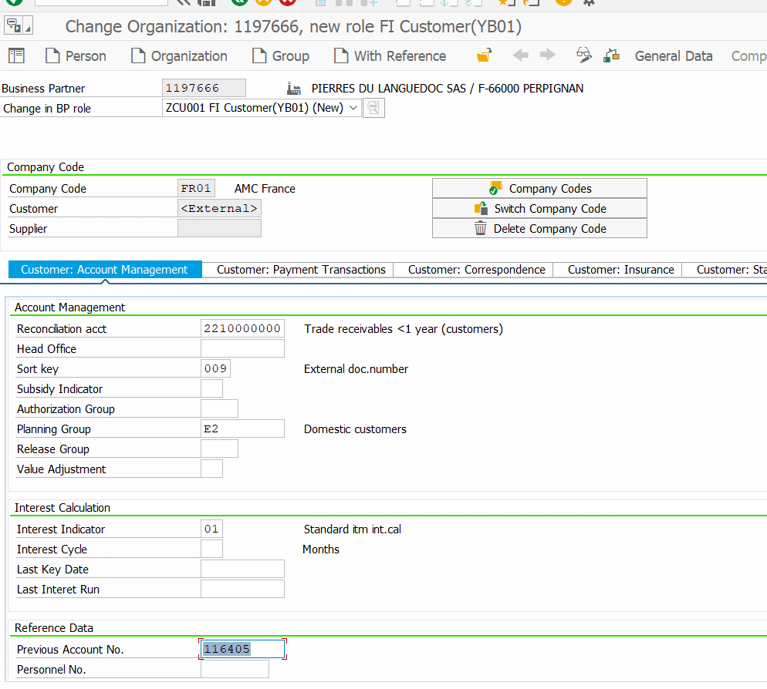
SOFI No
- SOFI number mention always in Quel Net- Fiches Form

- Customer: Payment Transaction Tab
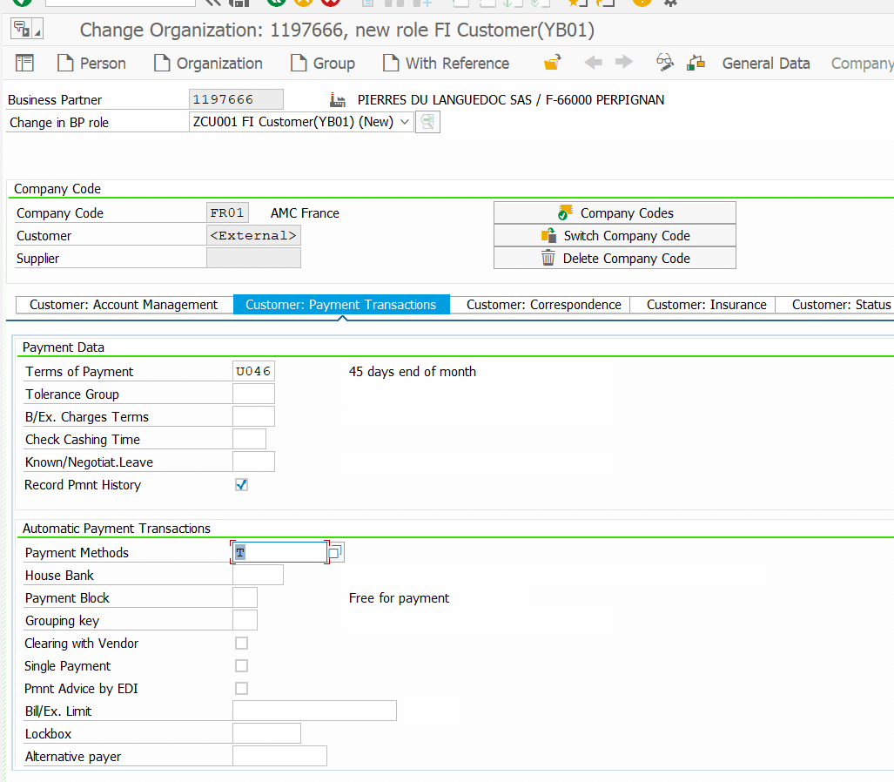
Cross check Payment Method & Attached legal pdf
- Customer: Correspondence Tab
- In Entity FR01, the Dunning Clerk (R1) and Accounting Clerk (99) should always remain the same as shown below.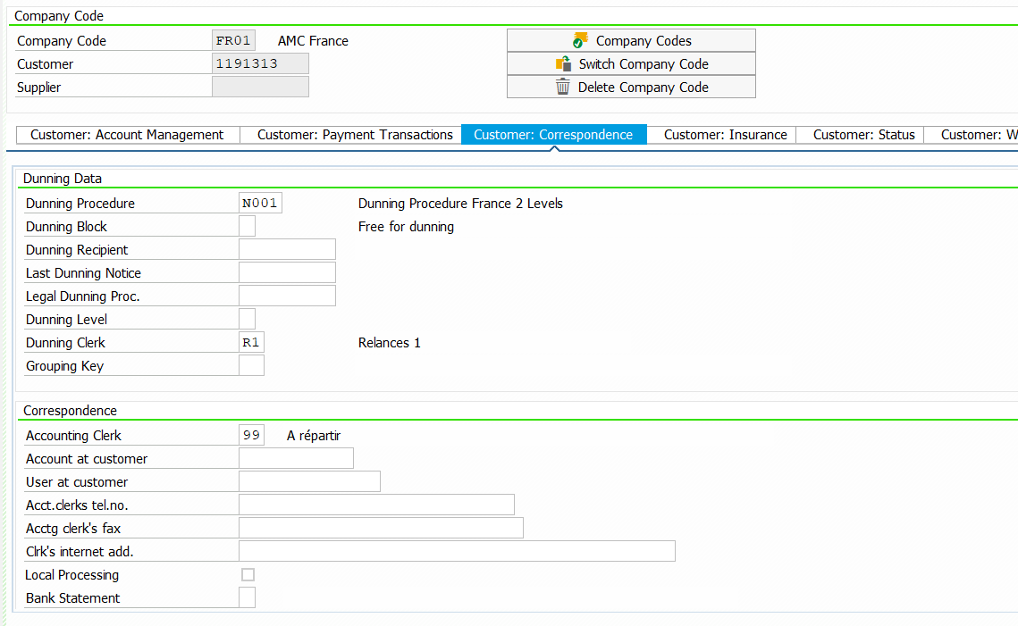
FR01-dunning key & Account Clerk same always

- Digital Correspondence Tab.
- Make sure 2nd Email address should be update as per below for Factura (Invoice) send via email
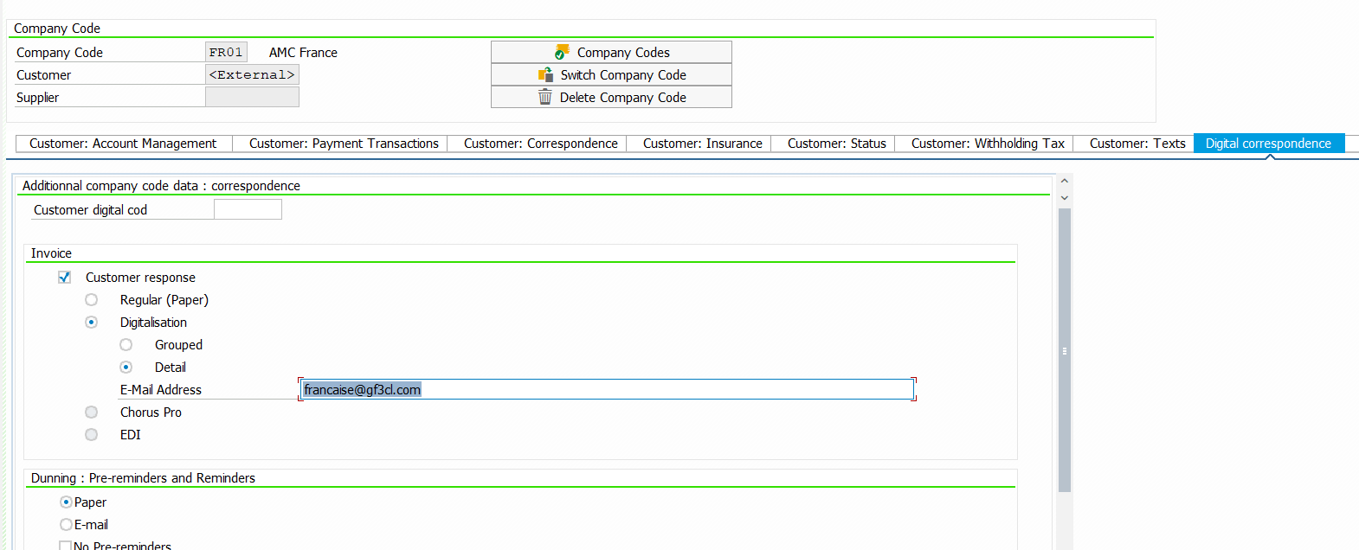

- New Scenario if FR01 Entity found in already system with other Entity in FR10
Then follow the below steps.
- First thing does not change anything.
- 1- Click on General Data and click on + symbol to add the address in Street 4 row
- And update Adress Tab, Identification (Update Siret No. Last two Digit)
- Payment Tab and Digital Correspondence Tab- 2nd Email address need to be update.
- Once update all Tab then saved.
- Click on Company Code and Click on Switch Company Code. 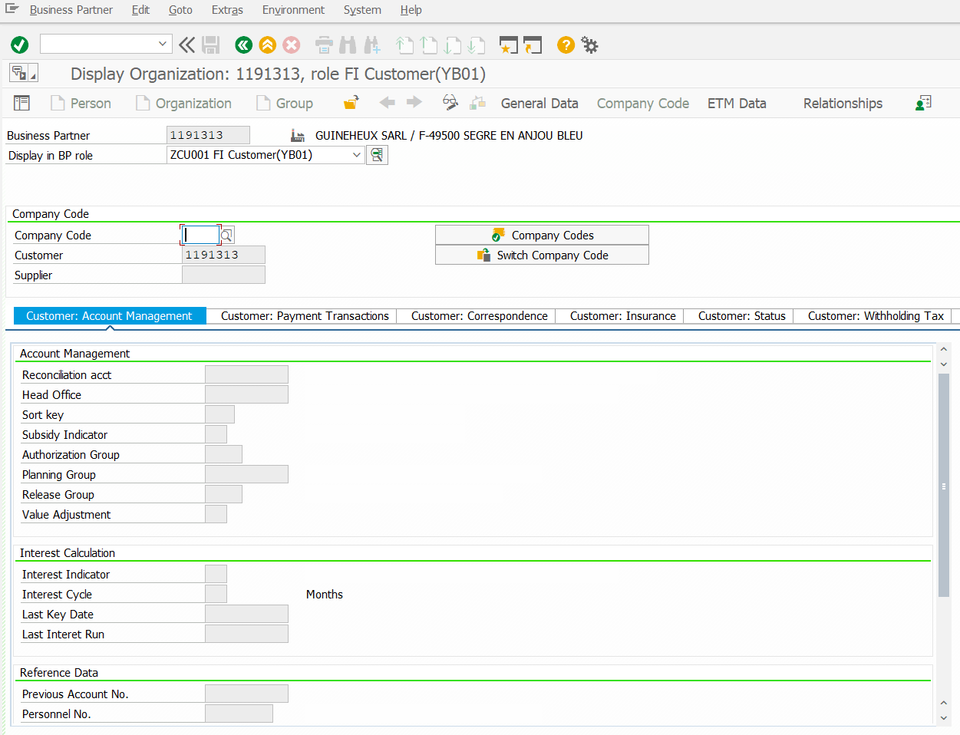
To change the Entity FR01

- As per below screenshot:
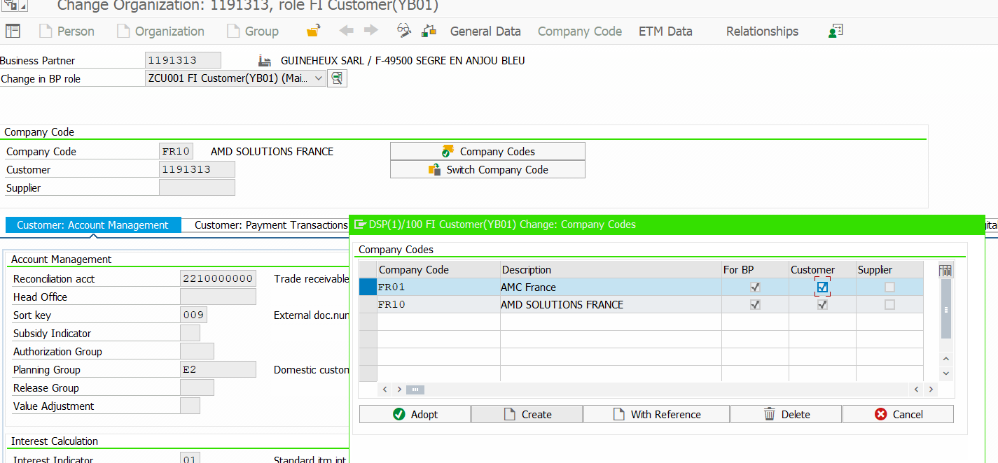
- Press Enter to start updating the other tab.

- Customer: Account Management
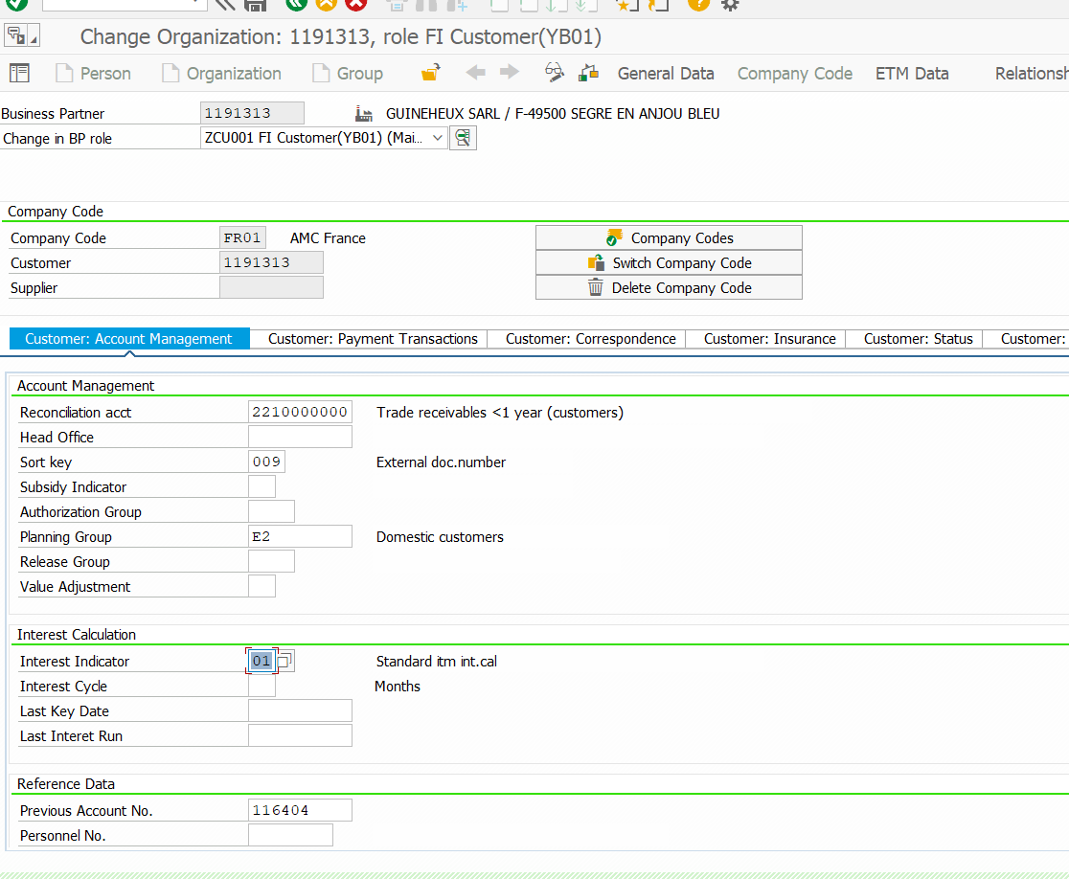
SOFI no- As per mention Fiches Appli

- Customer: Payment Transactions Tab
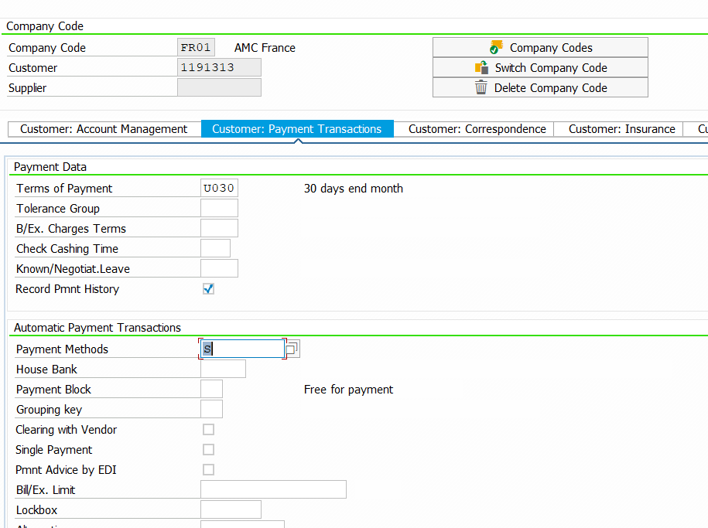
IF LCR-Direct- S & Upload Legal PDF
- Customer: Correspondence
By default, Same
By default, Same
- Digital Correspondence Tab
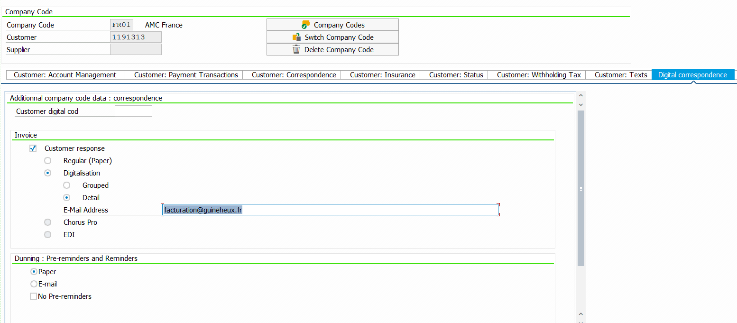
Inv Send via email (2nd Email add)
- Additional Tab:
Please update GPAO- X, as always.
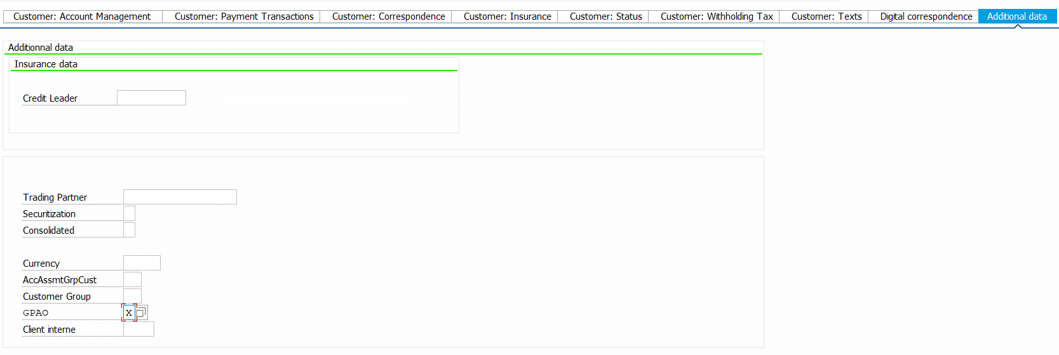
Saved.
- Go back to Fiches application page to update the below require status.
Client Id & X by default
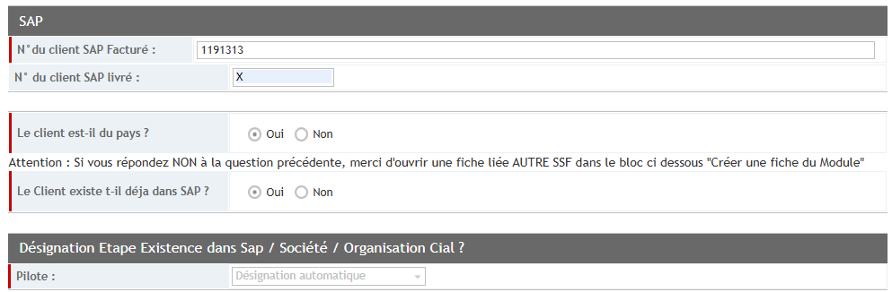
Is this cust already in SAP
Is the client from this country

- Click on Validate.
- Click the main screen again and update the details below.
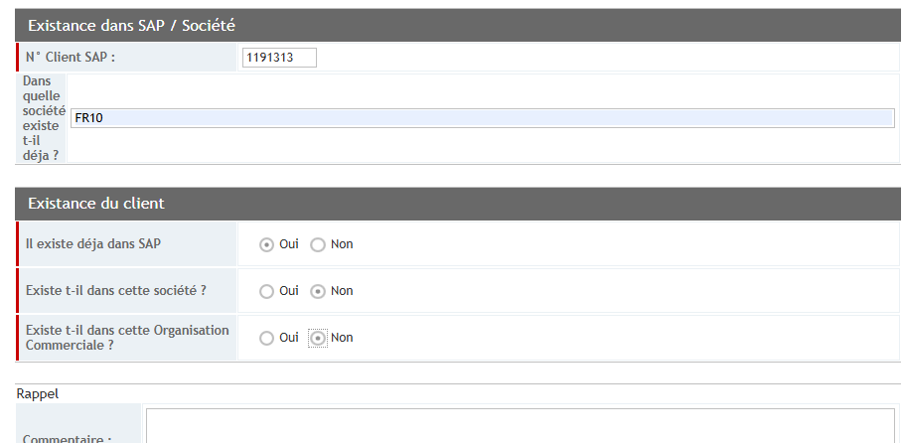
Already registered in this company (Means FR01 reqeust
Client already exists in SAP
Request found in other entity

Customer already exists in this Entity

- Click on Validate.

- Example: Modifying a customer account block. Follow the below steps
- Enter the T-Code - BP
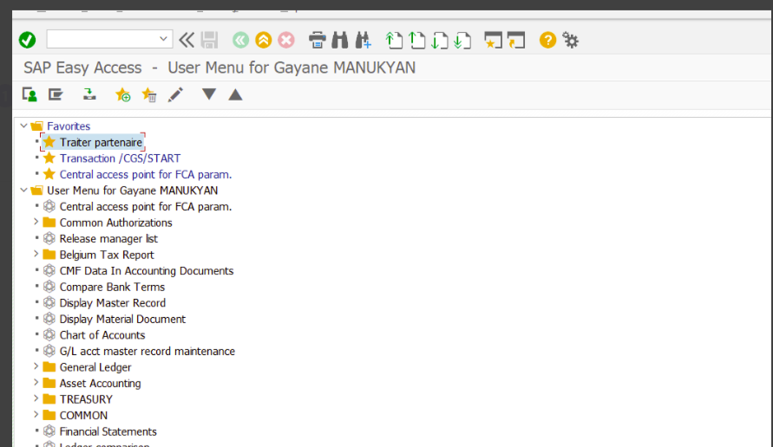

- Ente the Customer account as below Highlighted Column (Business Partner)
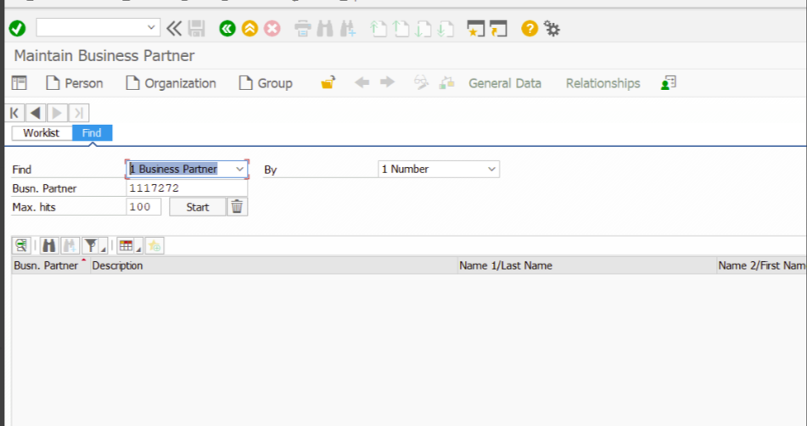
- Hit Enter to update entry, then click the line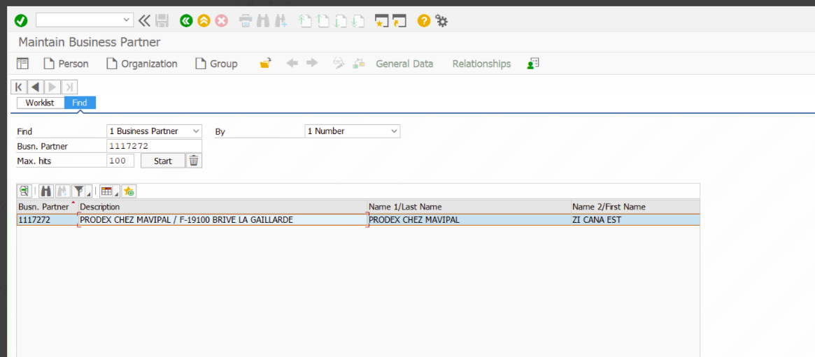

- Go to the Identification tab and copy the SIREN number to verify it matches the European Commission application
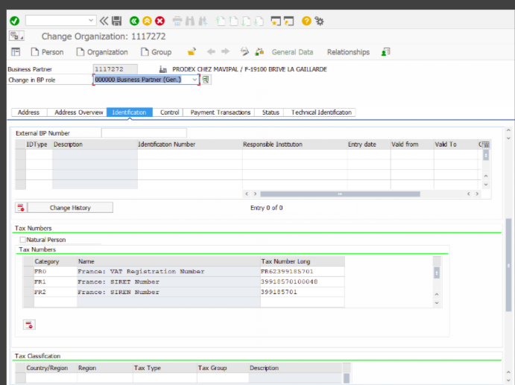
- Once the SIREN, SIRET, VAT number, and address match, block the customer account.
- In the Address tab, update the Name row with 'LIQUIDATION JUDICIAIRE + date' per EC application
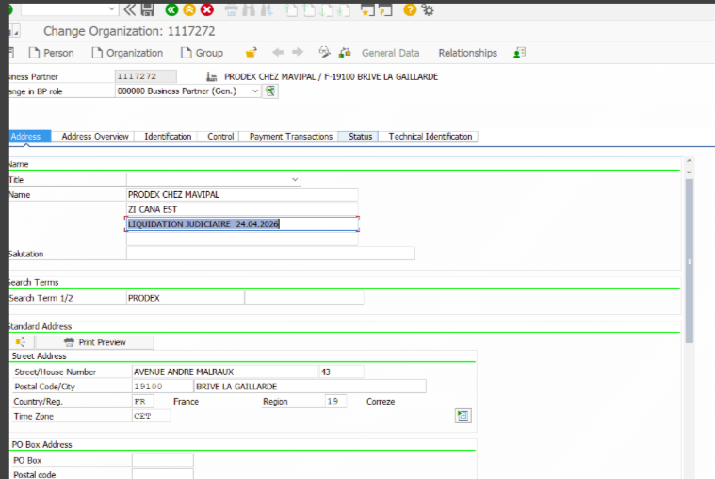

- 5.4- Example of customer account Block

- Now go to the Status tab to block the customer account.
Click on BOX- Archiving Flag
-Central Block
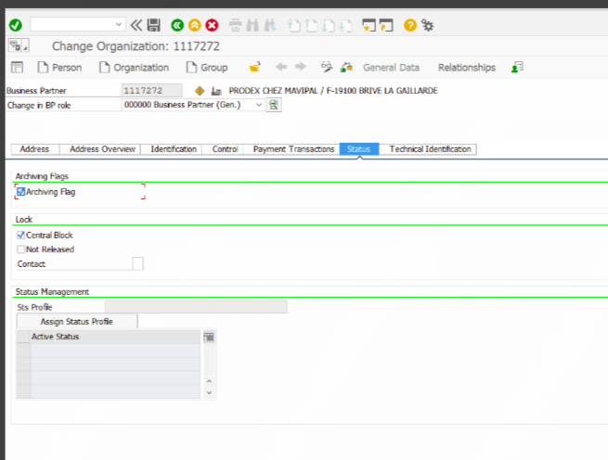
Click on status tab
- And click on Save and continue.
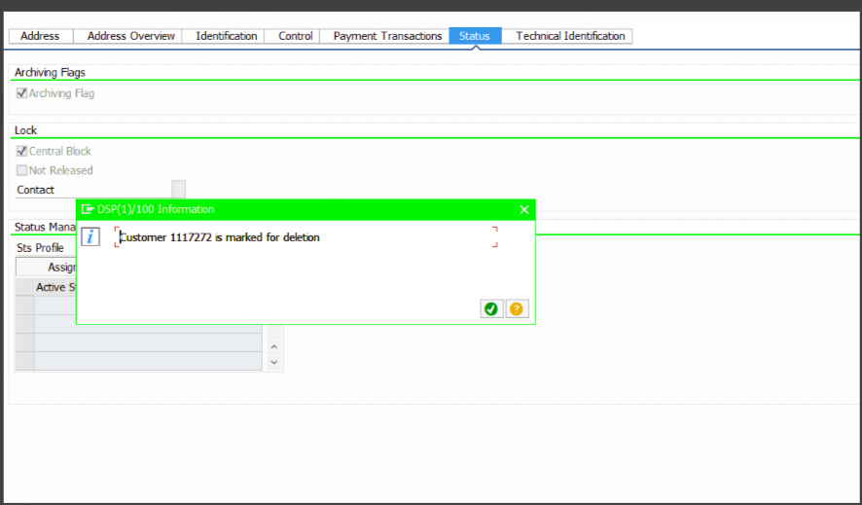

- Now change in BP Role-ZCU001-FI Customer (YB01) and go the Customer status Tab.
Click on Below box- AL Company Code
- Deletion Flag
- Deletion Block

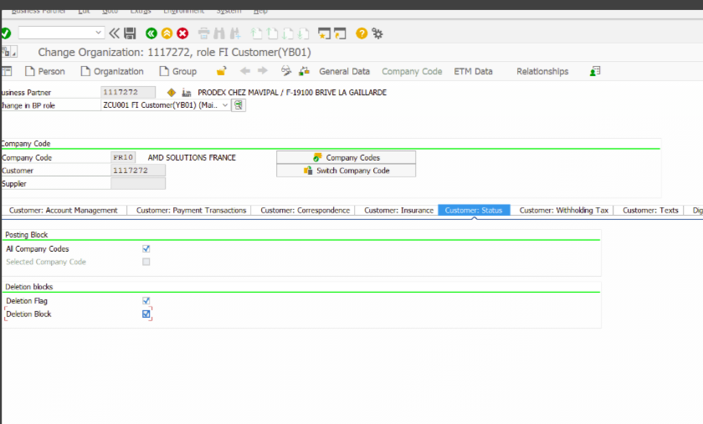
Click on Customer: Status
- Saved and update the status to the requestor via Qualnet application/ email.

UPDATES
- Please check and Update while creating customer account in system.
- Address Tab
Under Address Tab
Always Update address in CAPITAL LETTERS
- Order Tab
Do not enter any data in the Customer Group if 100% or 50% is not mentioned in the QuelNet portal | 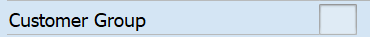
Under Order Tab
Customer Group | F1 | 100%
Customer Group | F2 | 50%
Order probability | Always Zero (0) | Always Zero (0)
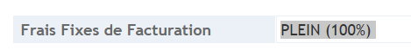
- Email ID:
Email ID updates
Facture | Invoice | If mentioned, update in the system; if not available, leave it blank.

2nd -Email
RELEVE/RELANCE | Dunning - pre- reminder -Paper | If mentioned, update in the system; if not available, leave it blank.
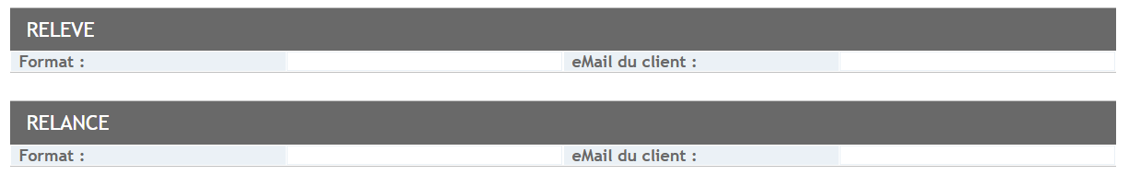
3- Payment Method Details:
Payment Method |  | Document required | If the document is not found in the Quel Net Portal, then
LCR DIRECT | S | With proper signature, stamp, and documents | Payment method take - NP
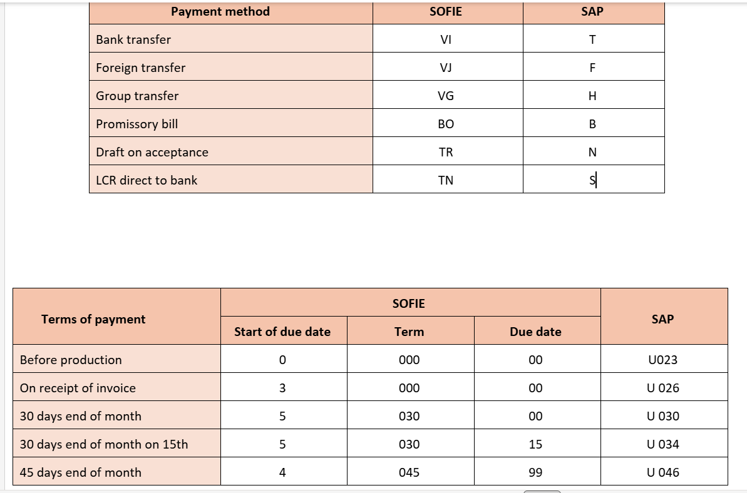
For cash payment its U 001

FOR DUPLICATE CASES-
Case1- Duplicate with all details.
In this case we do not refuse the qualnet file, we will submit it with already exist
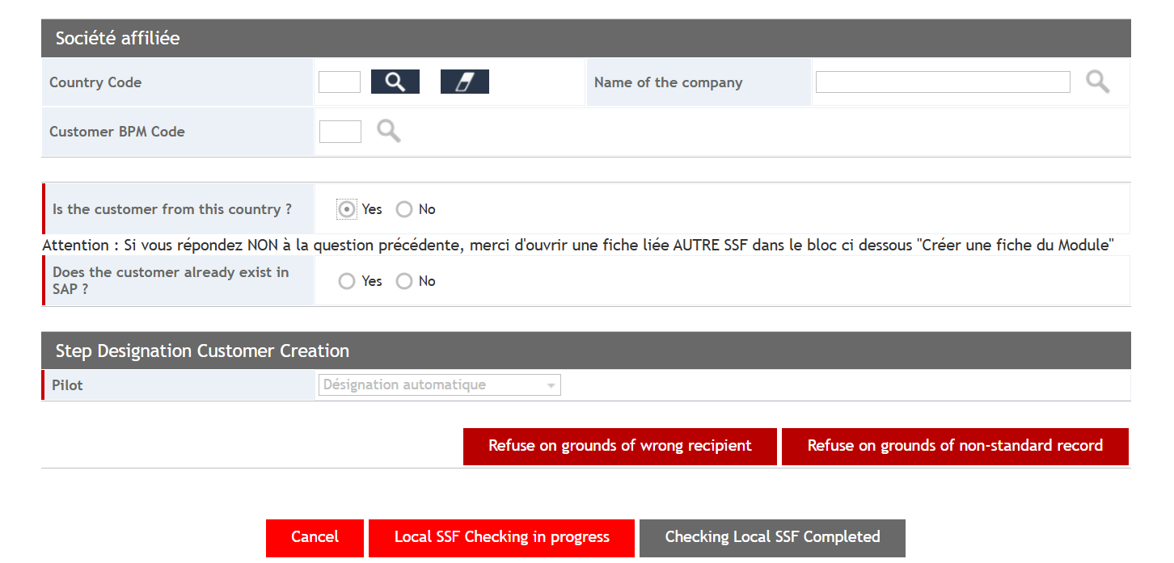
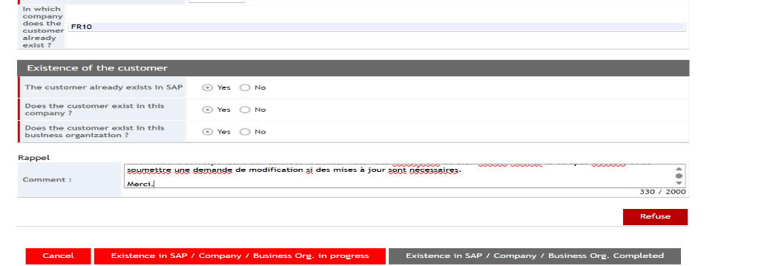

Case2- Duplicate with some details.
In this case we refuse the file.

